


Photo and video documentation from TTX and FSX
I. Pictures from TTX in Lviv.
II. Situational pictures of chosen FSX sites.
III. Film from FSX: https://m.youtube.com/watch?fbclid=IwAR0MKe6dfxclEN45ouMbMcj_Lda4CXdS2HFx8qHVE_RXPPpuMDyfx9gUkKc&v=28Rx2G6NJGY&feature=youtu.be
IV. FSX Worksites
V. Media information about FSX (with photos):
https://tvrmoldova.md/article/1f71d694e4fdaae7/peste-150-de-pompieri-din-romania-ucraina-letonia-dar-si-din-alte-trei-tari-au-venit-in-republica-moldova-pentru-a-participa-la-un-exercitiu-tactic.html;
https://realitatea.md/foto-exercitiul-de-teren-la-scara-larga-euro-med-react-a-fost-finalizat/;
https://protv.md/actualitate/simulare-de-incendii-la-ialoveni-mai-multi-salvatori-si-pompieri-din-sase-tari-veniti-in-moldova-au-participat-la-exercitii-de-teren-la-scara-larga-foto---2660308.html;
https://ambulanta.md/participarea-echipelor-amu-la-exercitiu-de-teren-la-scara-larga-euro-med-react-2023/;
https://www.dse.md/ro/communicate/echipele-interna%C8%9Bionale-de-salvatori-%C8%99i-pompieri-care-particip%C4%83-%C3%AEn-exerci%C8%9Biul-de-teren;
https://www.dse.md/ro/communicate/echipele-interna%C8%9Bionale-de-salvatori-%C8%99i-pompieri-care-particip%C4%83-%C3%AEn-exerci%C8%9Biul-de-teren;
https://www.dse.md/ro/communicate/start-exerci%C8%9Biului-de-teren-la-scar%C4%83-larg%C4%83-%E2%80%9Eeuro-med-react%E2%80%9D-2023-foto-igsu;
https://www.facebook.com/dse.md/;
https://radiomoldova.md/p/16937/150-rescuers-from-several-countries-came-to-the-republic-of-moldova-for-a-large-scale-joint-exercise-for-the-first-time-volunteer-fire-teams-are-inv;
https://esp.md/ro/sobytiya/2023/07/12/exercitiu-euro-med-react-echipele-internationale-de-salvatori-si-pompieri-au;
https://protv.md/actualitate/peste-140-de-salvatori-din-sase-tari-au-ajuns-in-moldova-pentru-a-participa-la-un-exercitiu-de-lichidare-a-consecintelor-unor-inundatii-incendii-sau-accidente-chimice-foto-video---2660191.html ;
https://radiochisinau.md/exercitiul-de-teren-euromedreact-2023-sa-incheiat-salvatorii-din-republica-moldova-si-alte-6-tari-au-lichidat-dezastre-simulate---183211.html;
https://orizont.tv/ro/2023/07/12/salvatori-din-sase-tari-au-venit-in-moldova-vor-simula-interventii-la-inundatii-incendii-si-accidente-chimice-radiologice-si-nucleare-video/.

I. Pictures from TTX in Lviv and Chisinau.

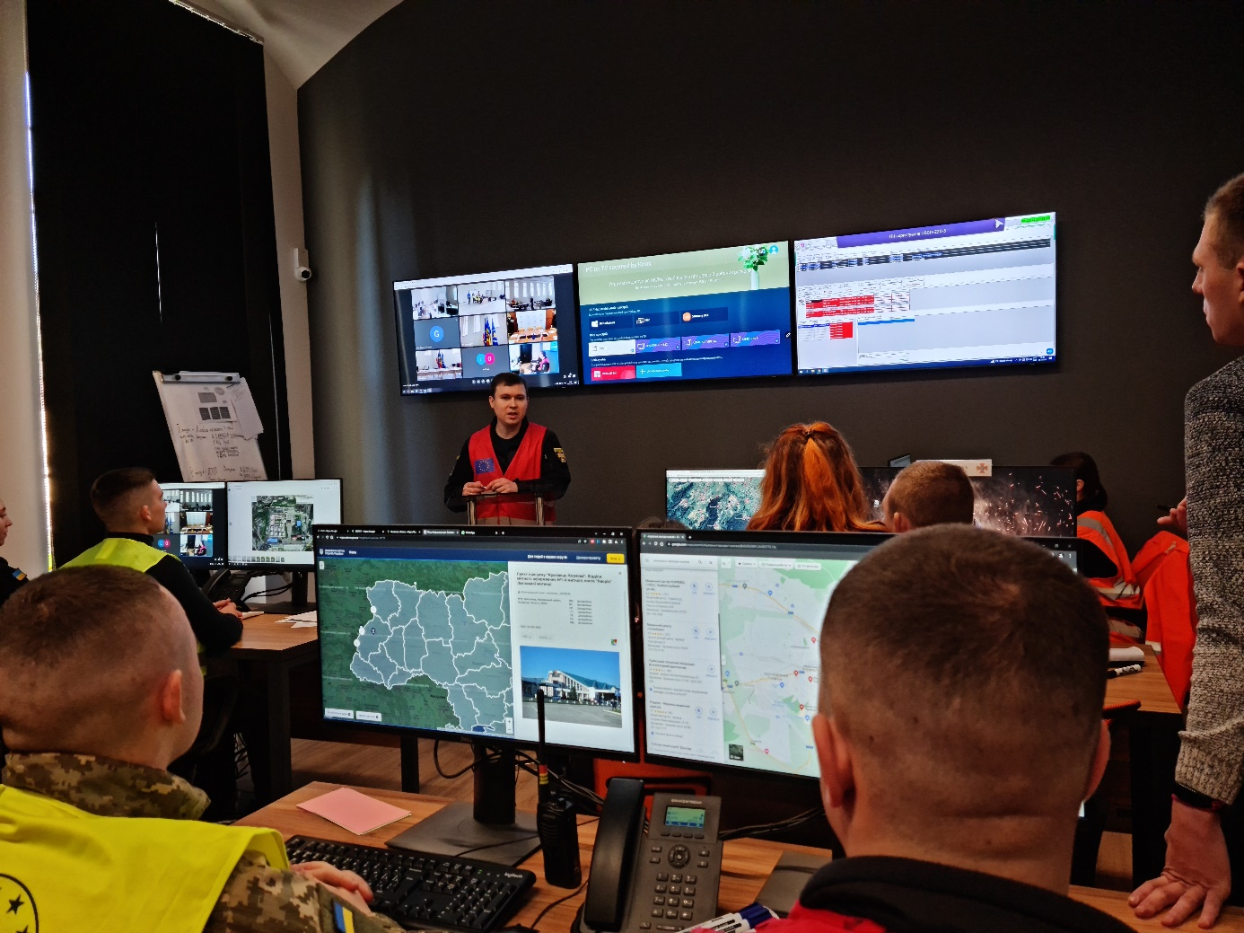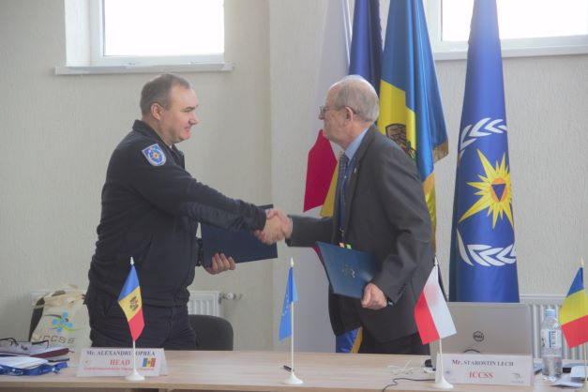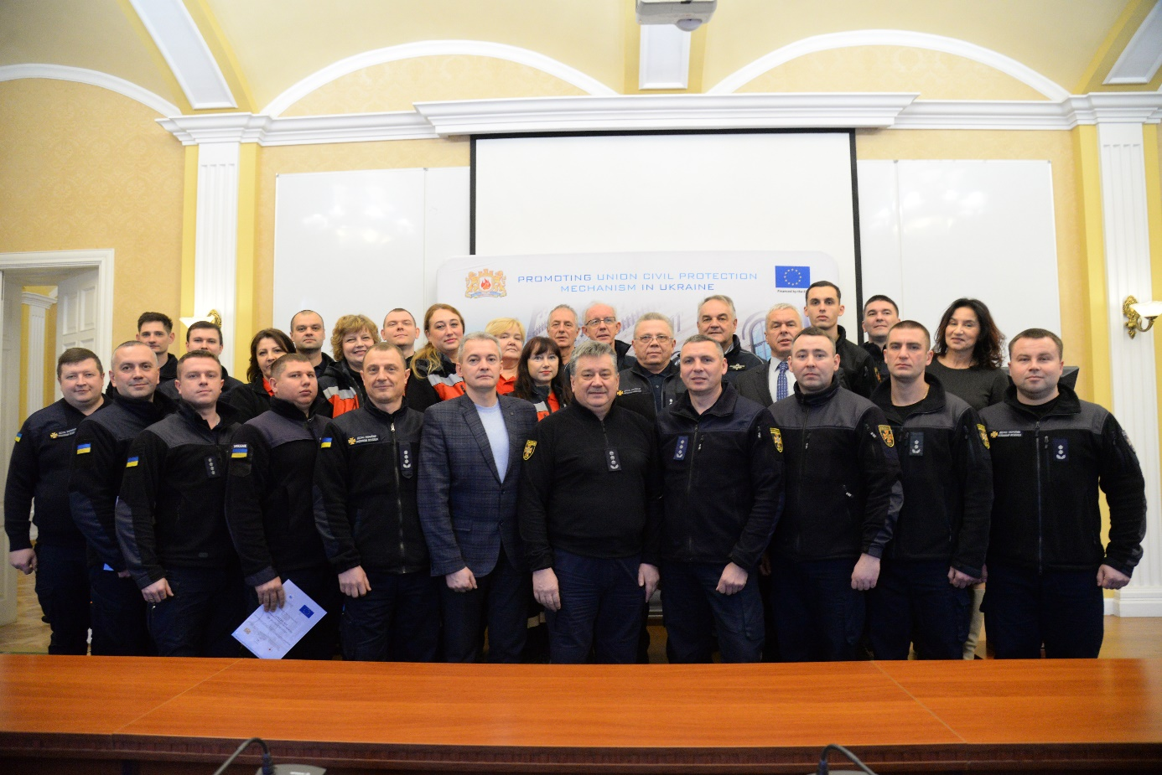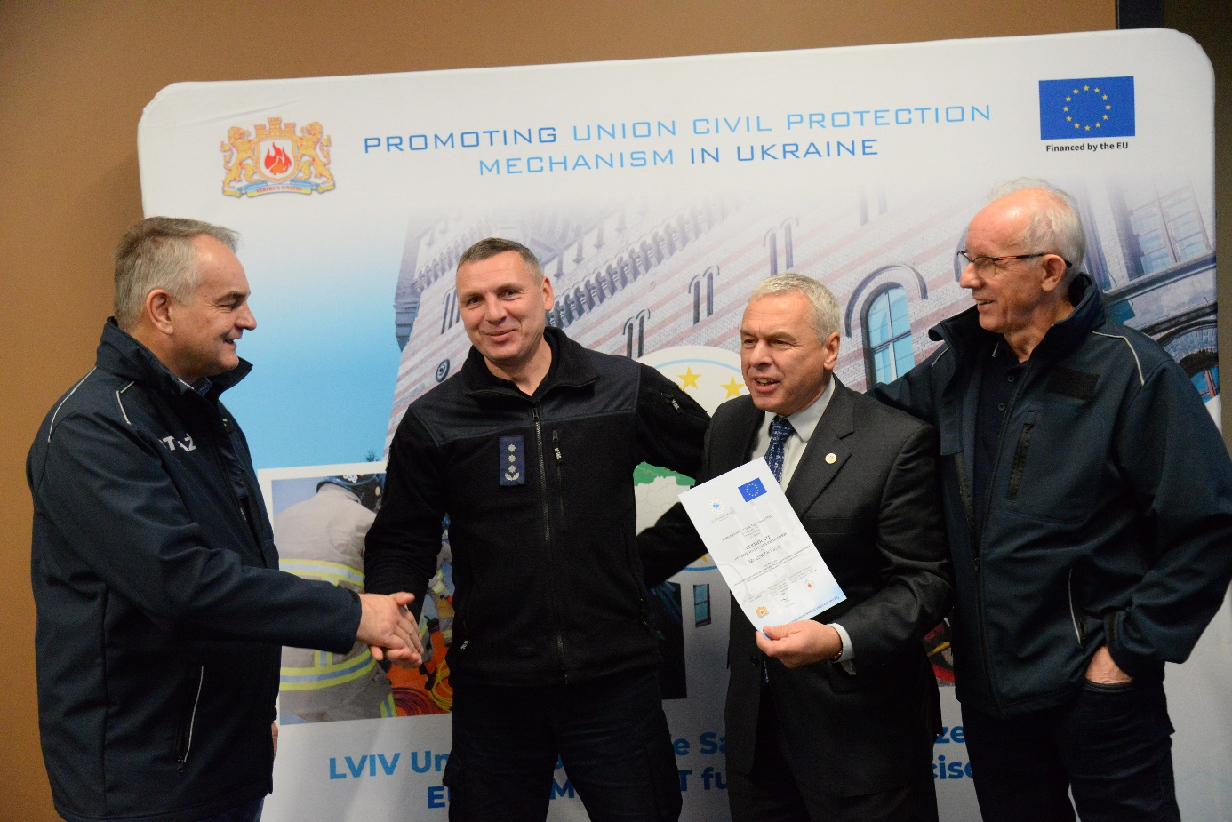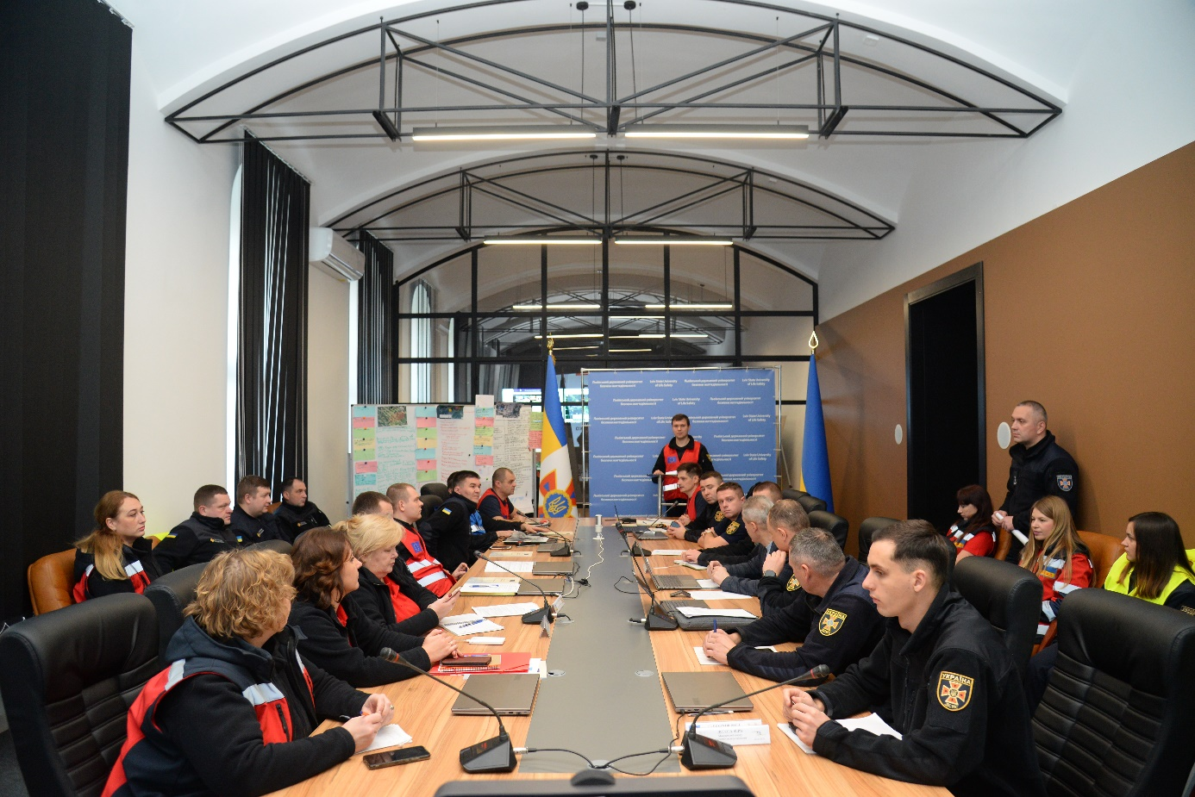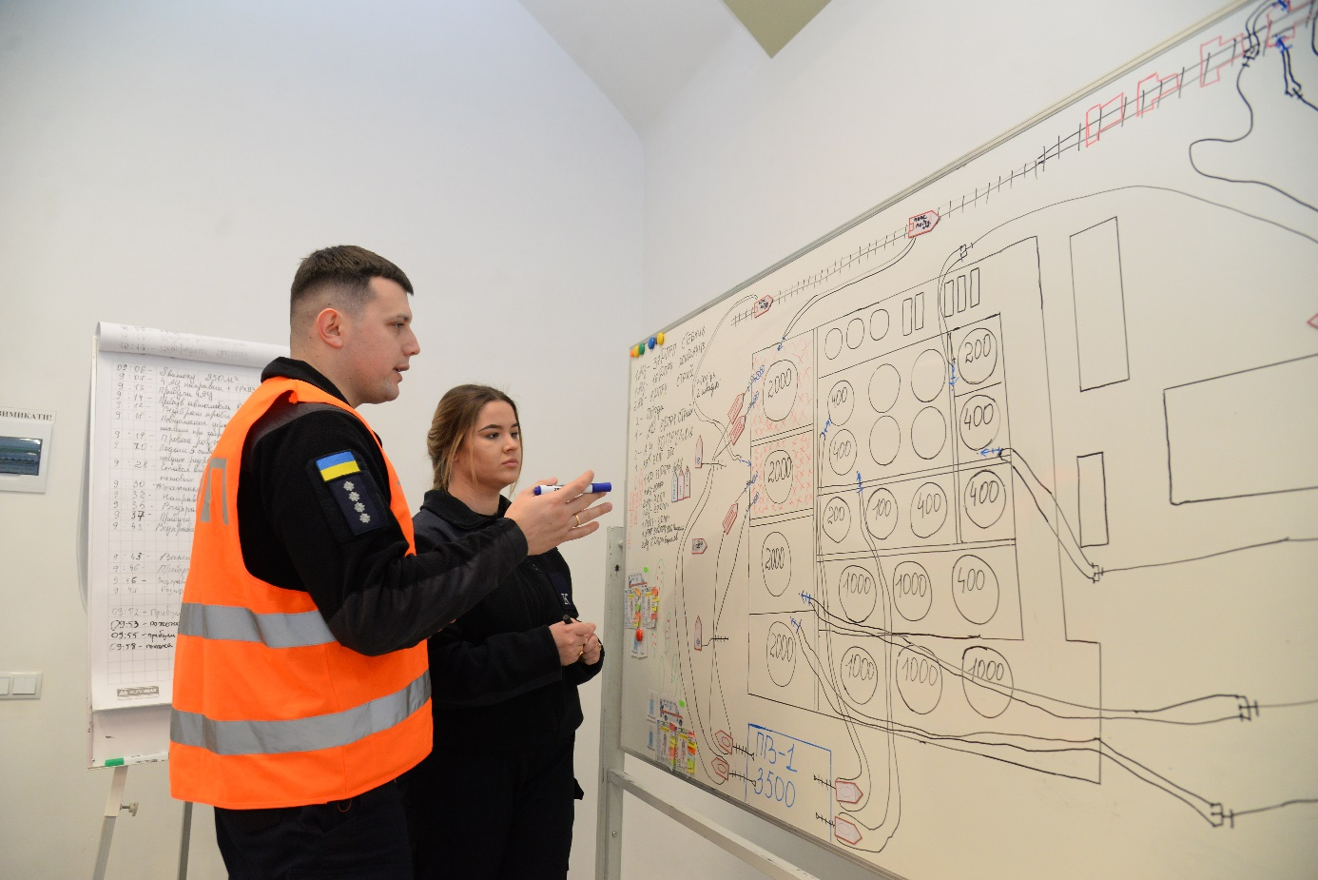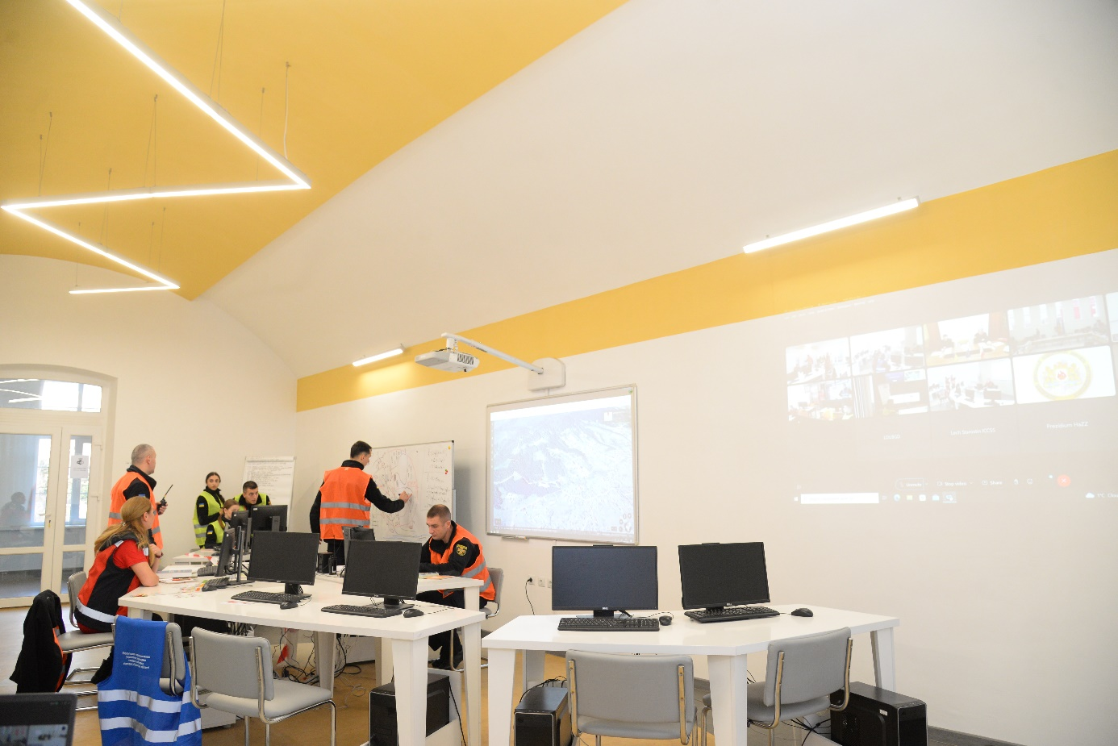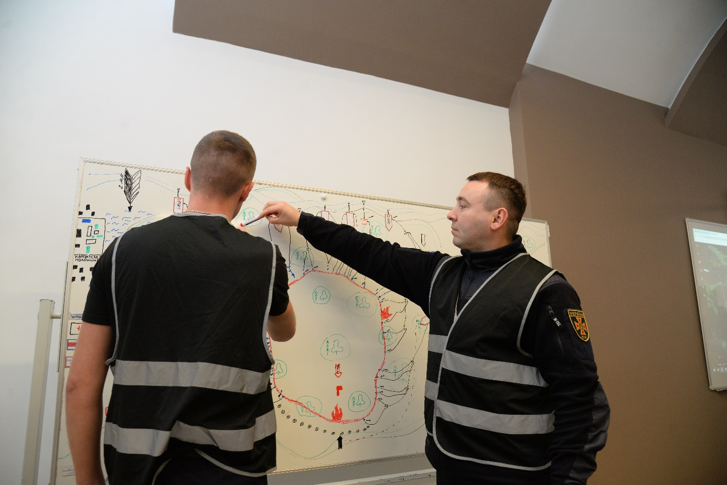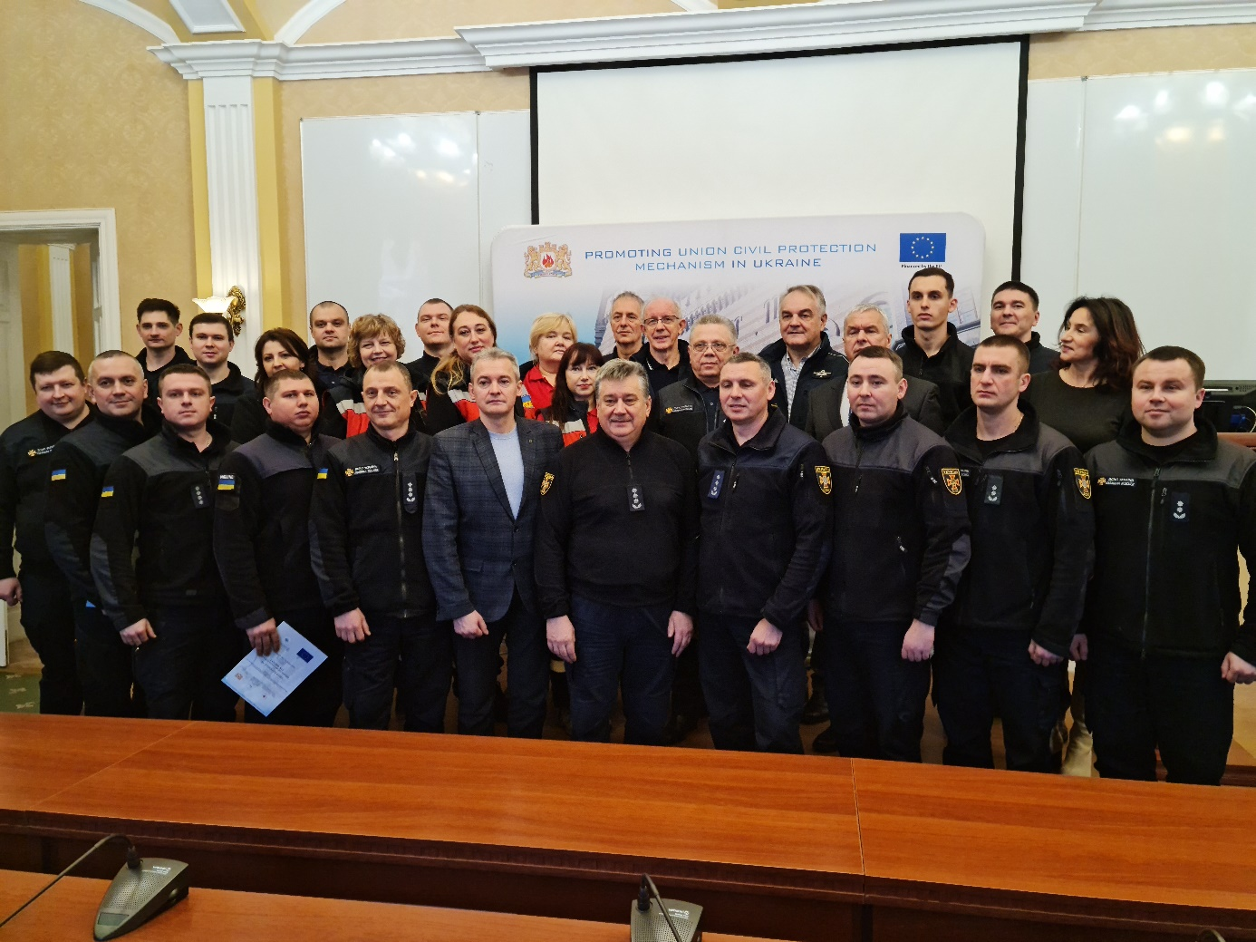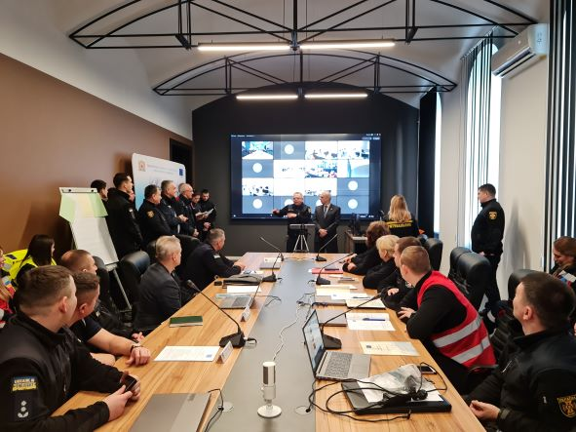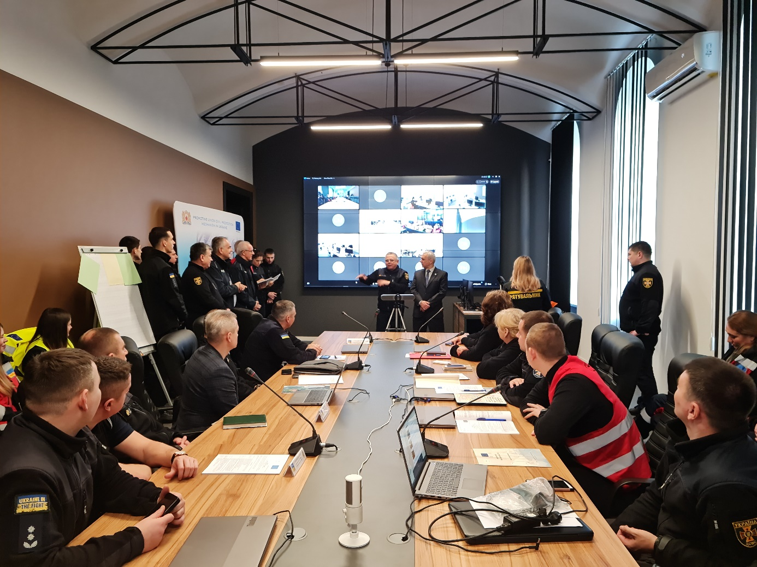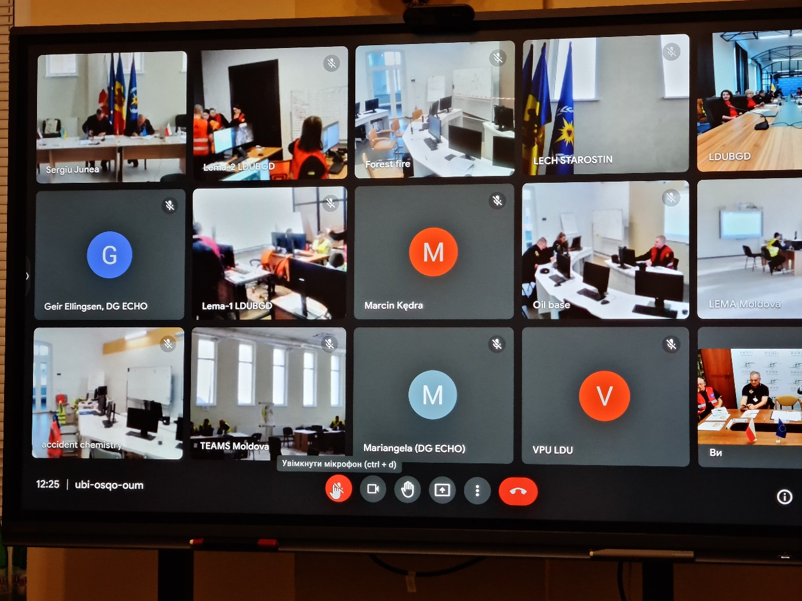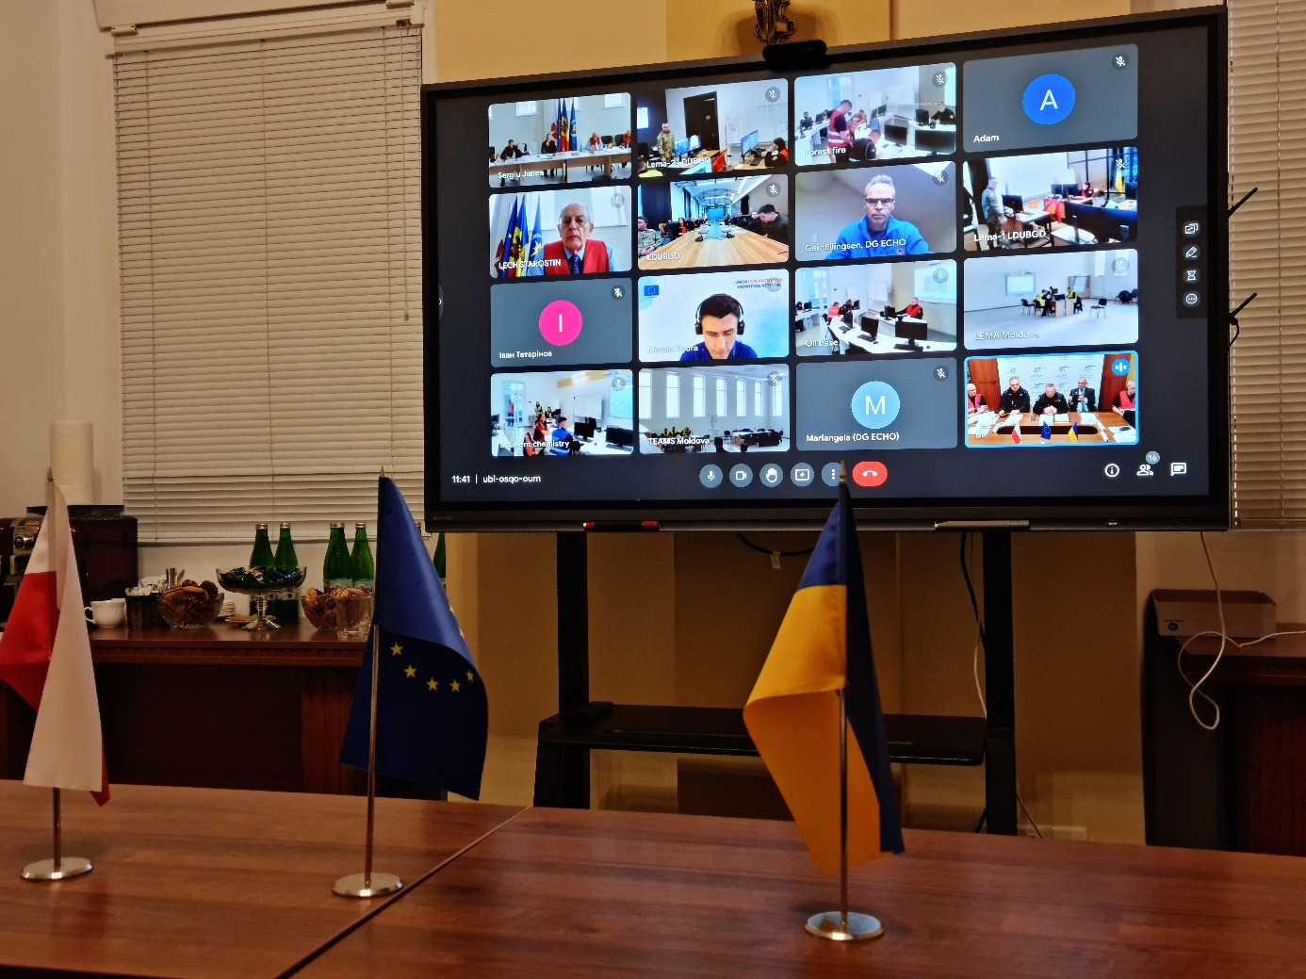
II. Situational pictures of chosen FSX sites.
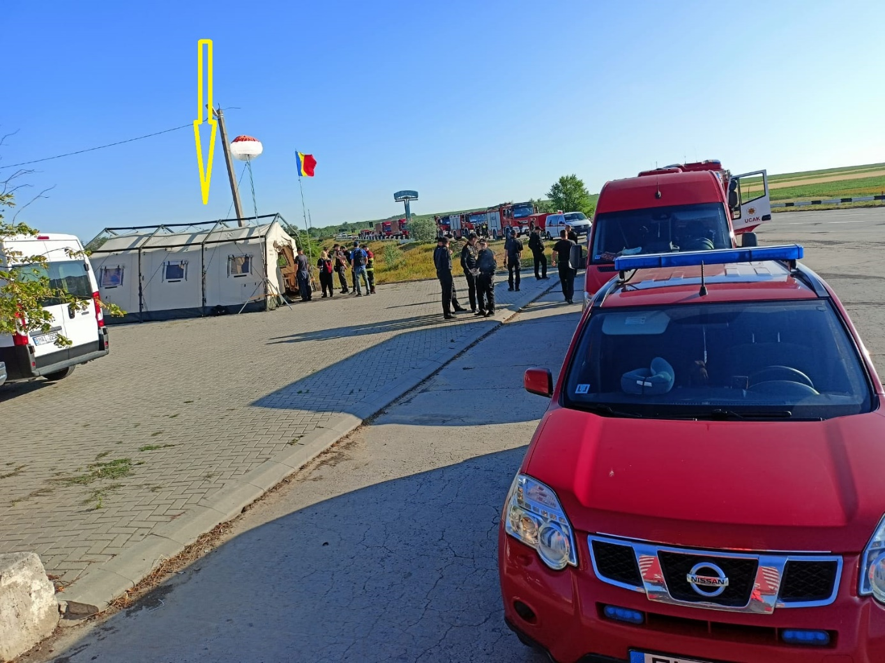
Reception and Departure Centre of the FSX.
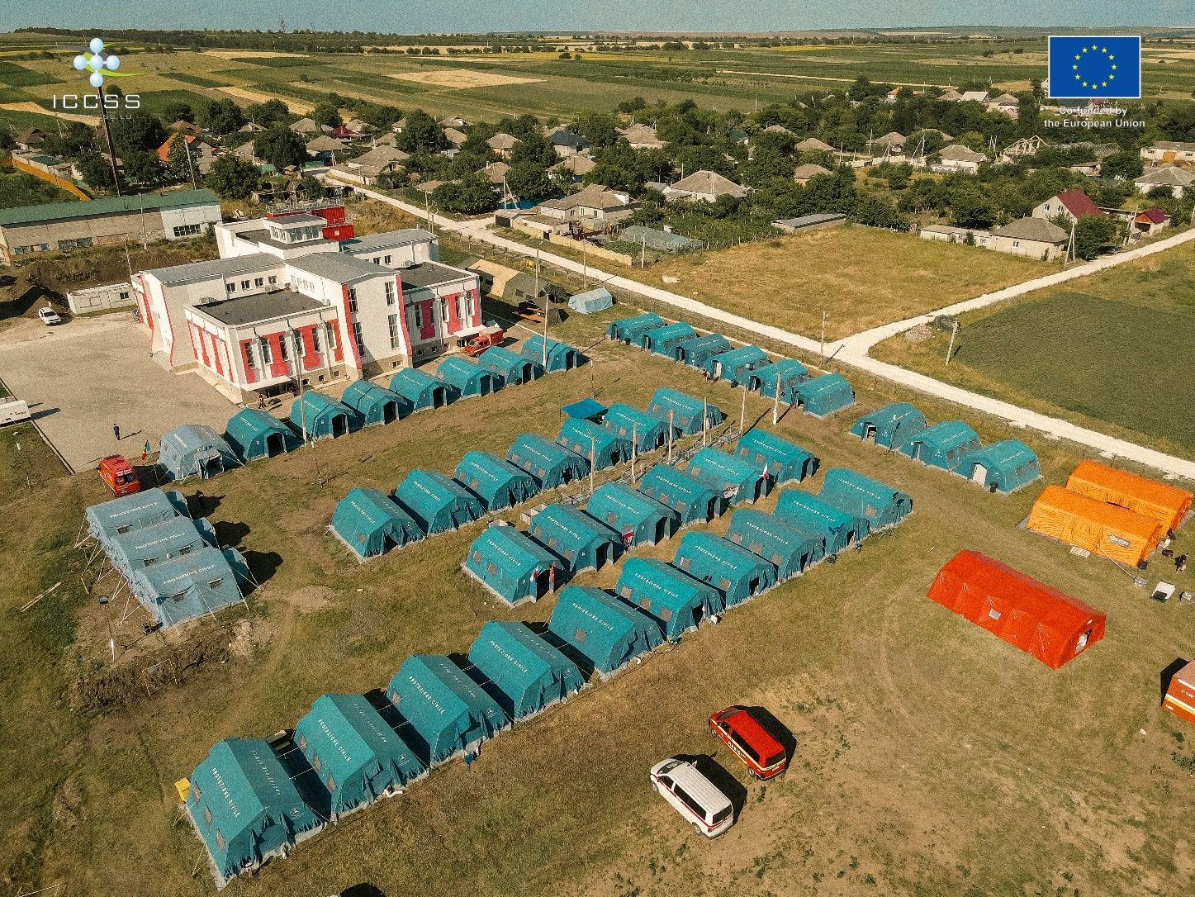
Base of Operations of the FSX. Behind the tents building with premises of LEMA, UCPTeam and PMT/EXCON is located.

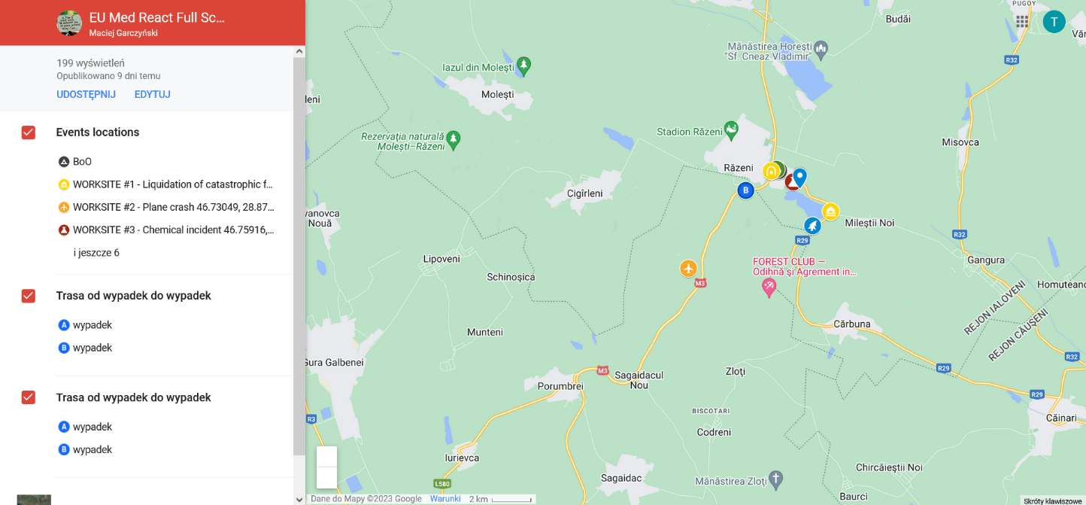

Picture 1. The map of individual scenarios’ locations.
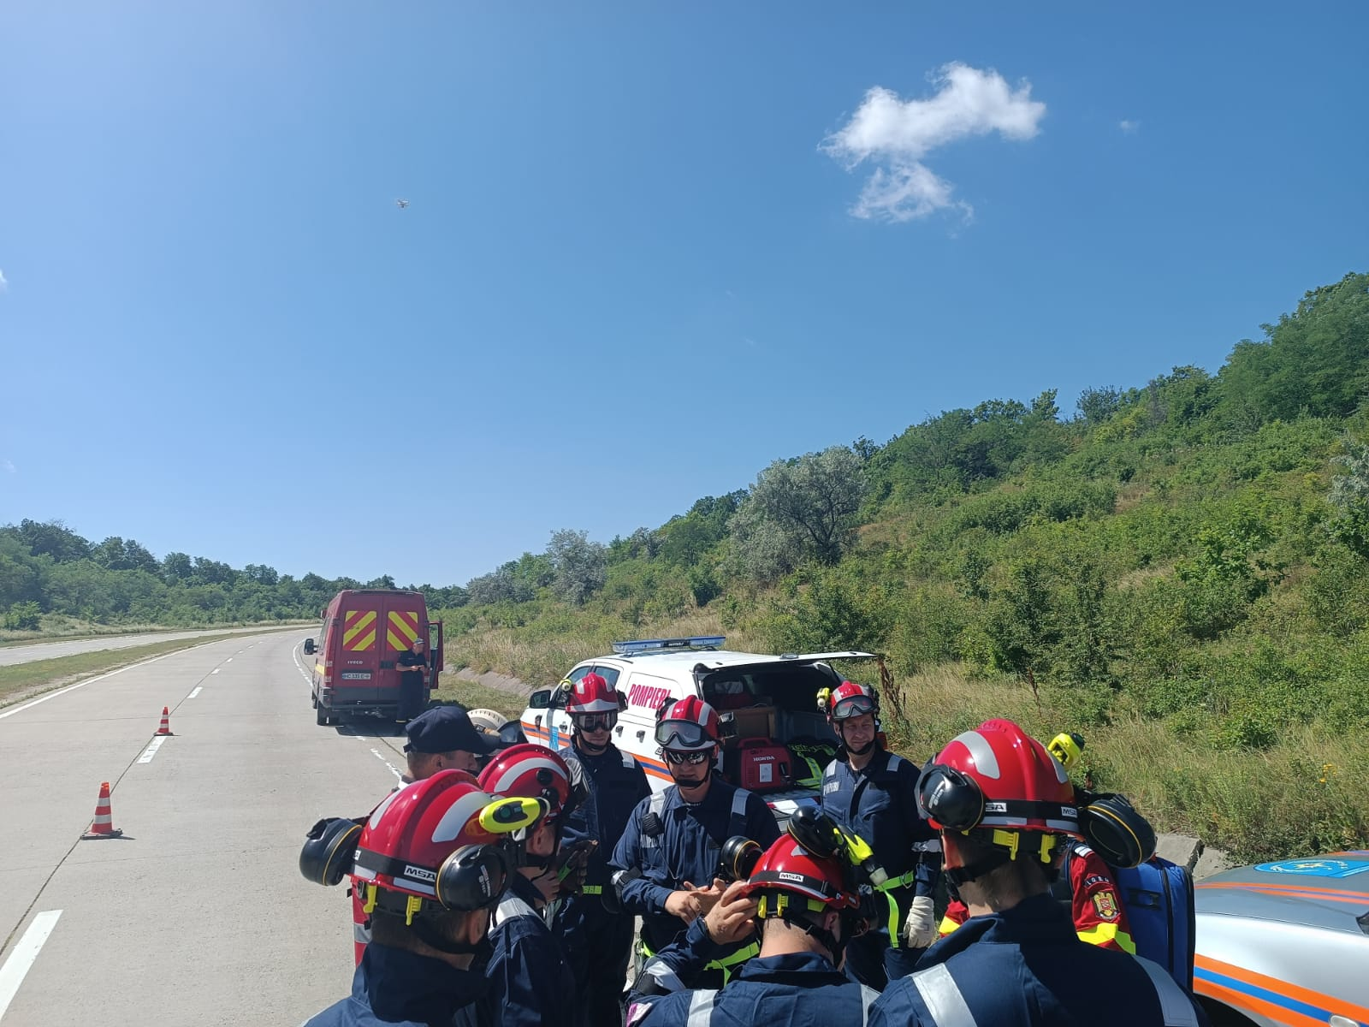
Picture 2. The briefing before search and rescue operation of the aeroplane’s crew.
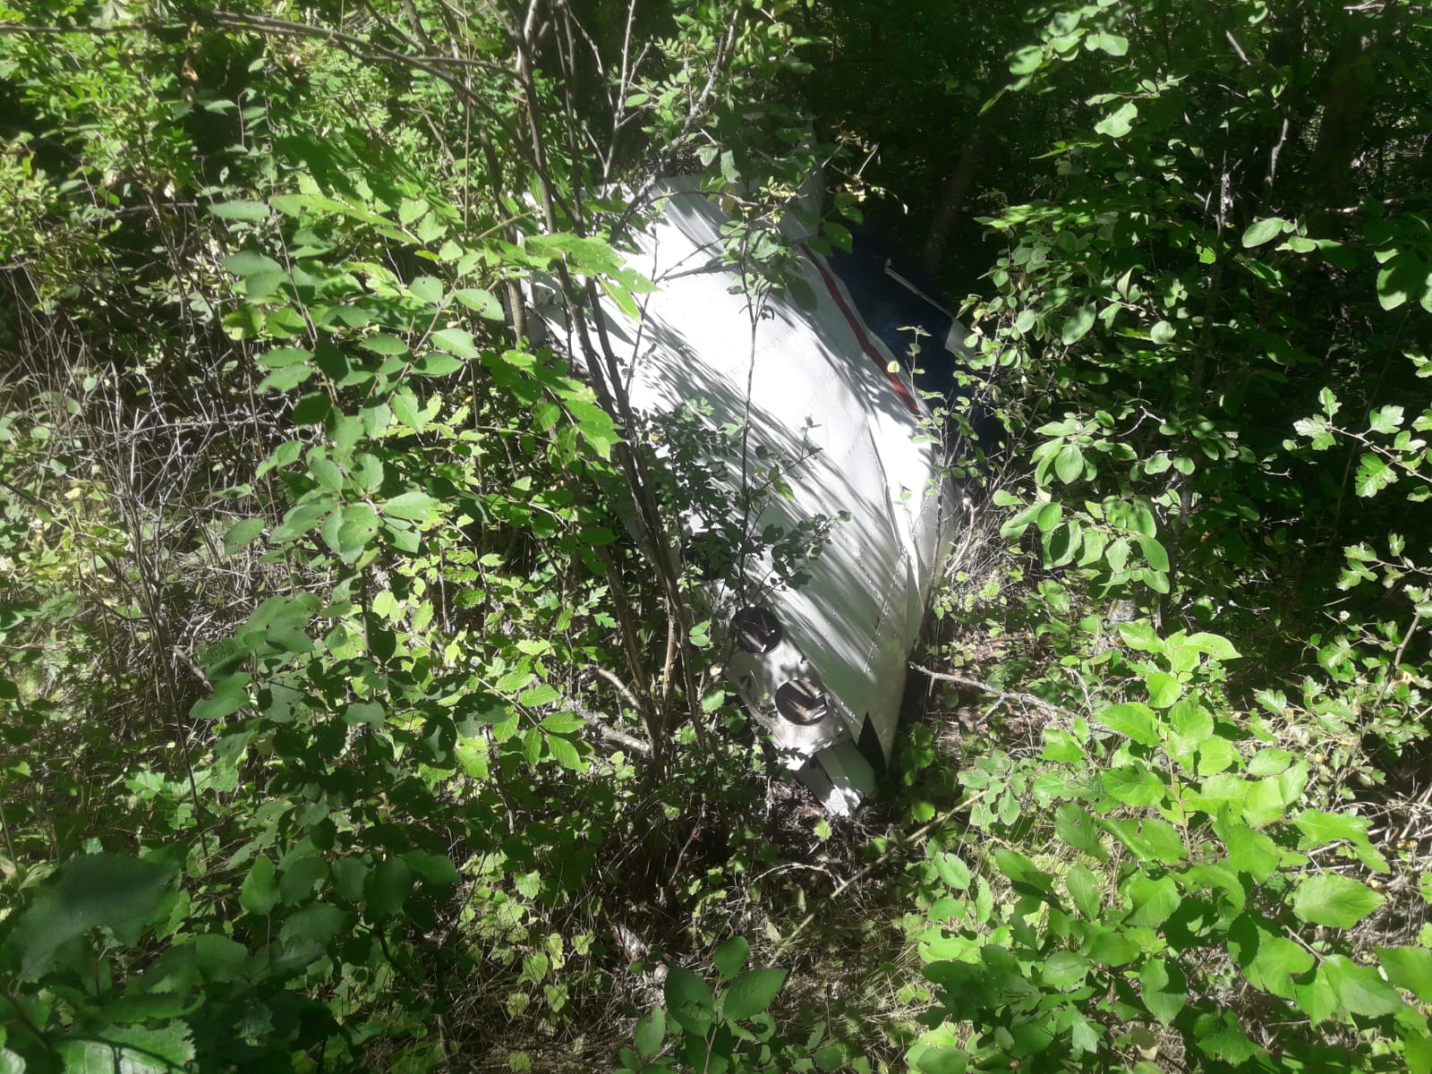
Picture 3. The wreckage of the aeroplane.
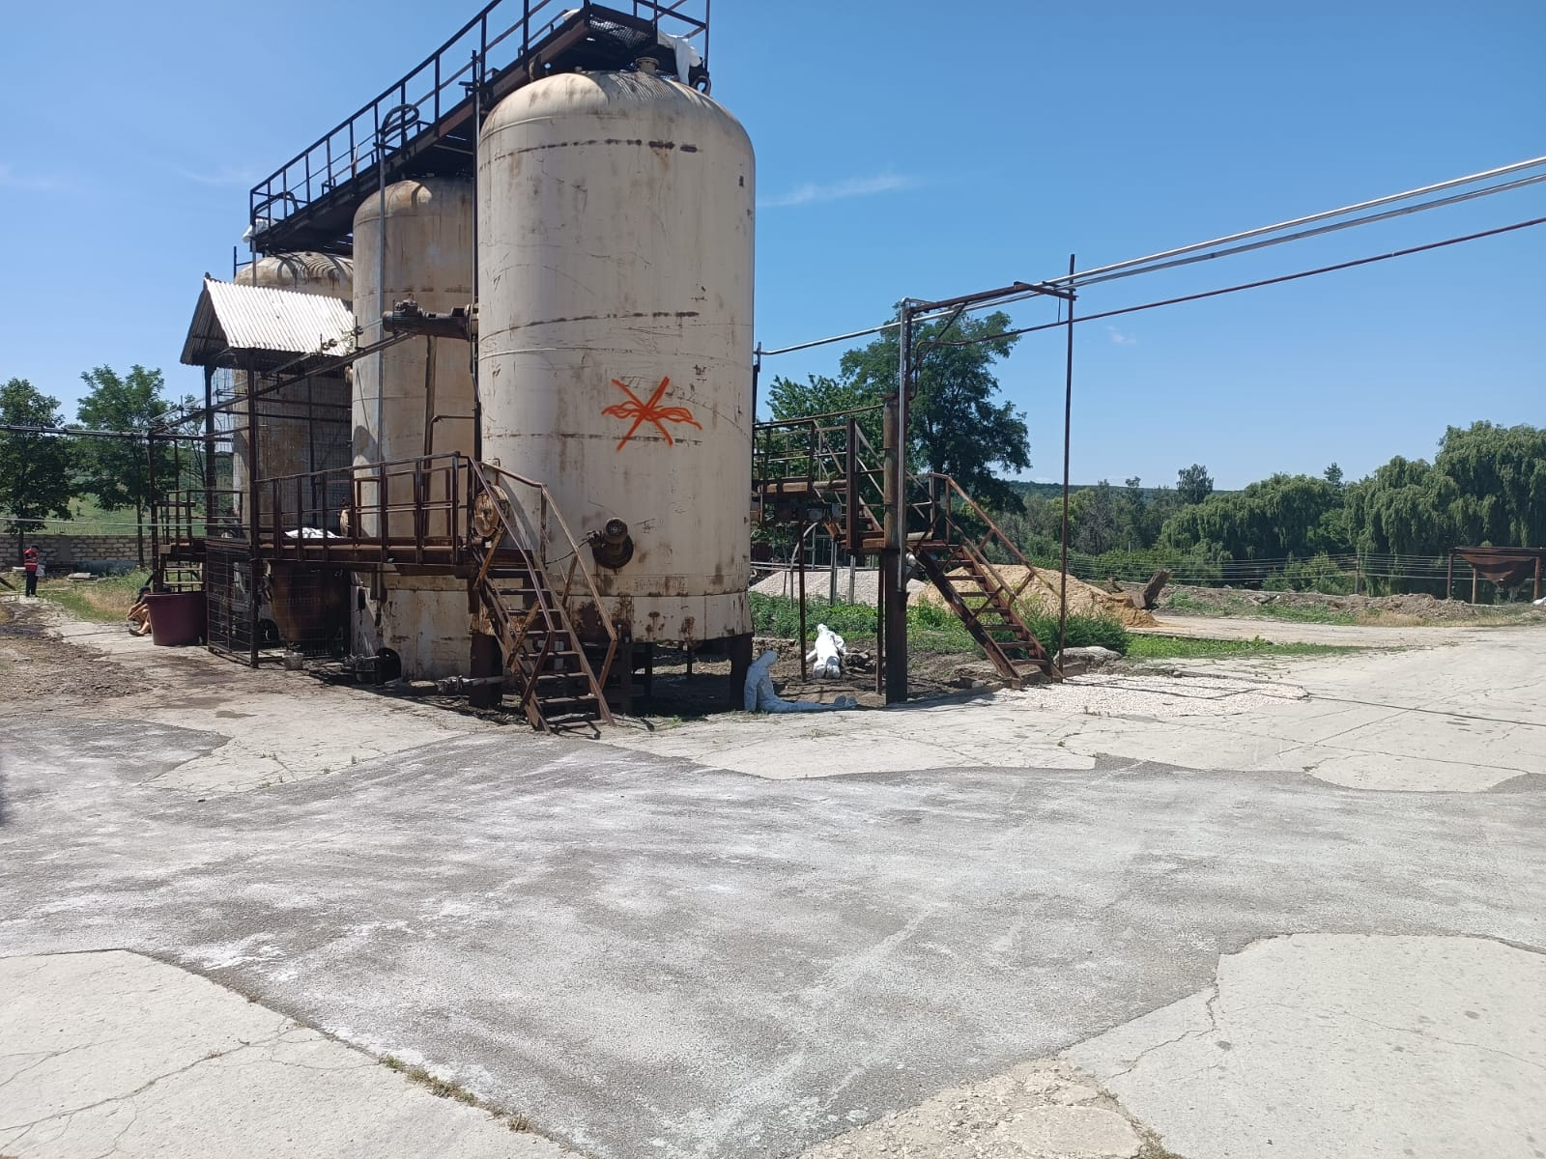
Picture 4. The incident in the chemical plant.
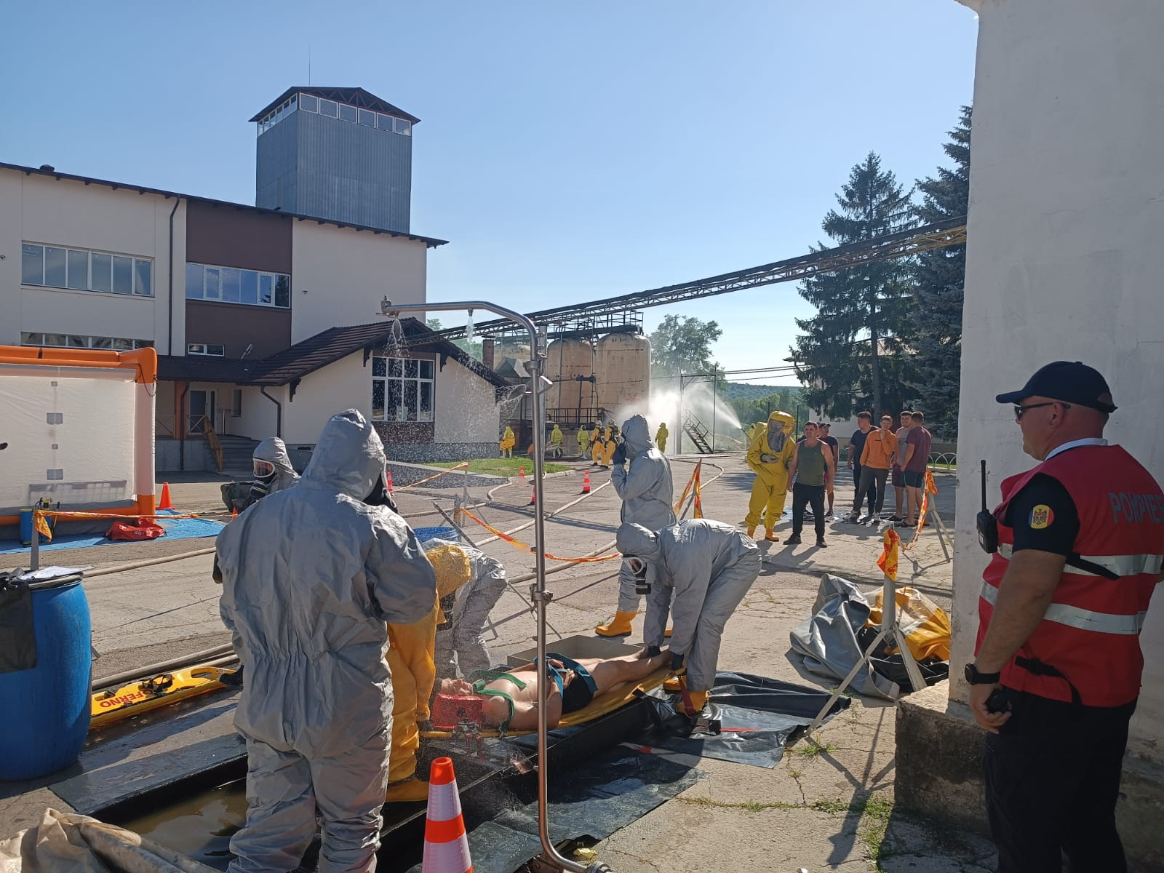
Picture 5. The incident in the chemical plant.
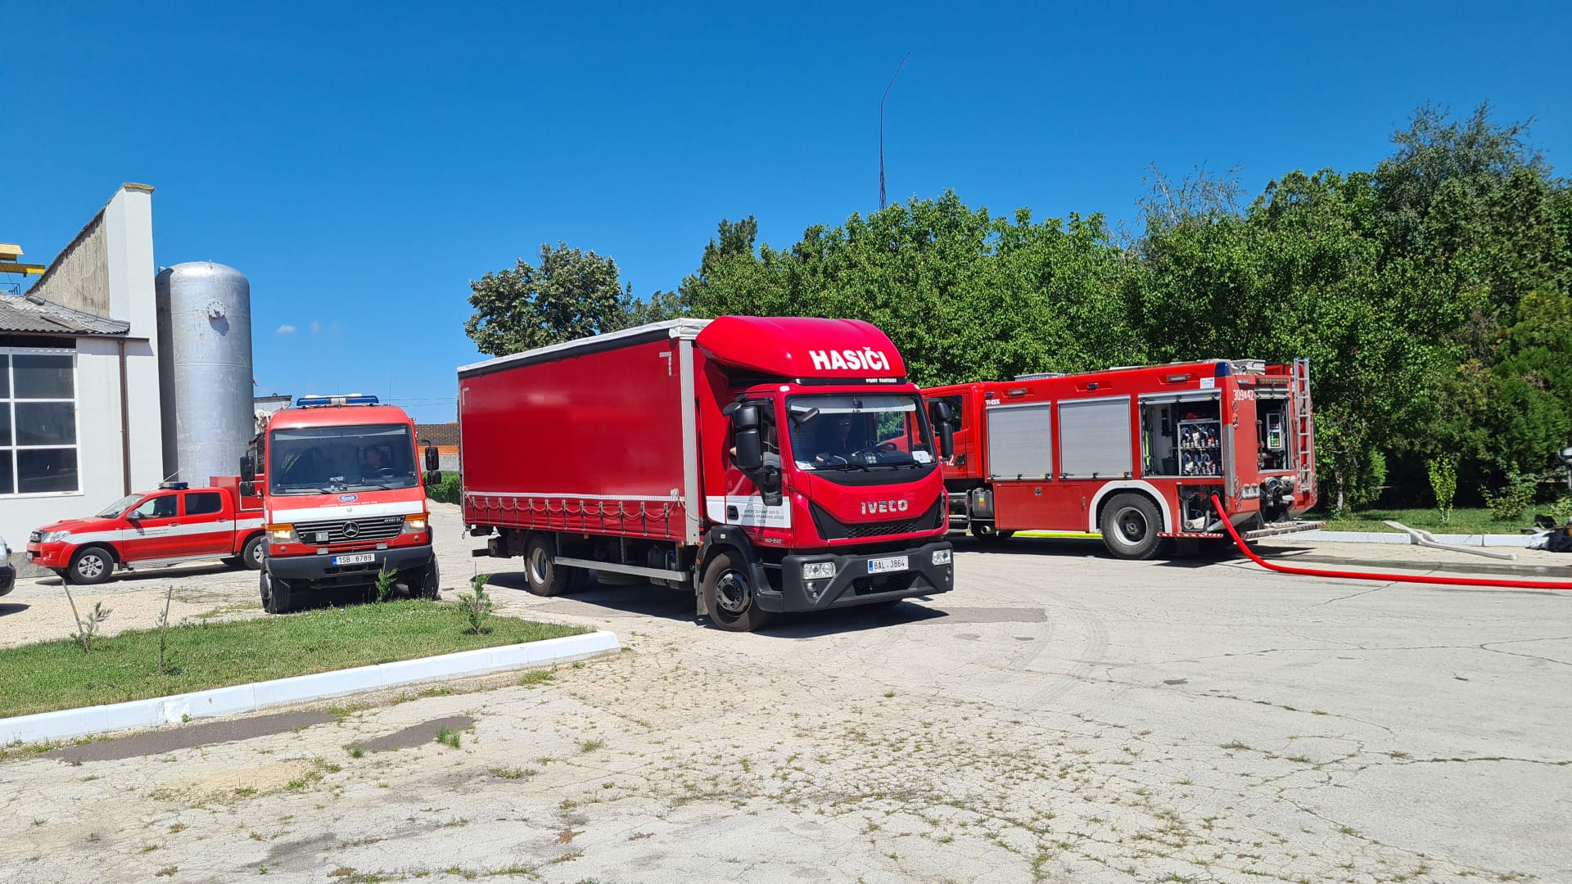
Picture 6. The incident in the chemical plant.
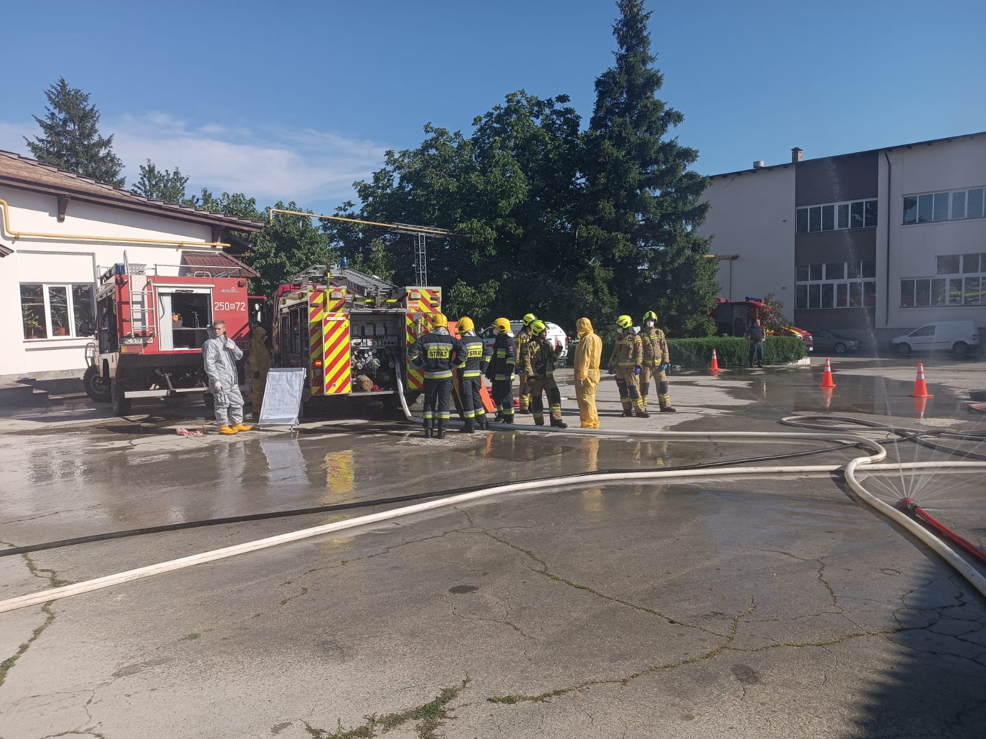
Picture 7. The incident in the chemical plant.
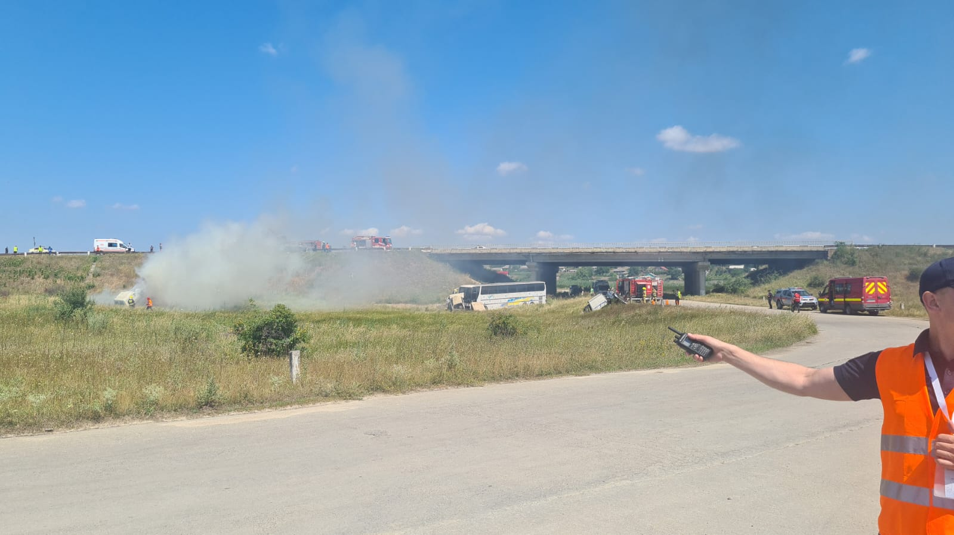
Picture 8. The complex accident in the road transportation.
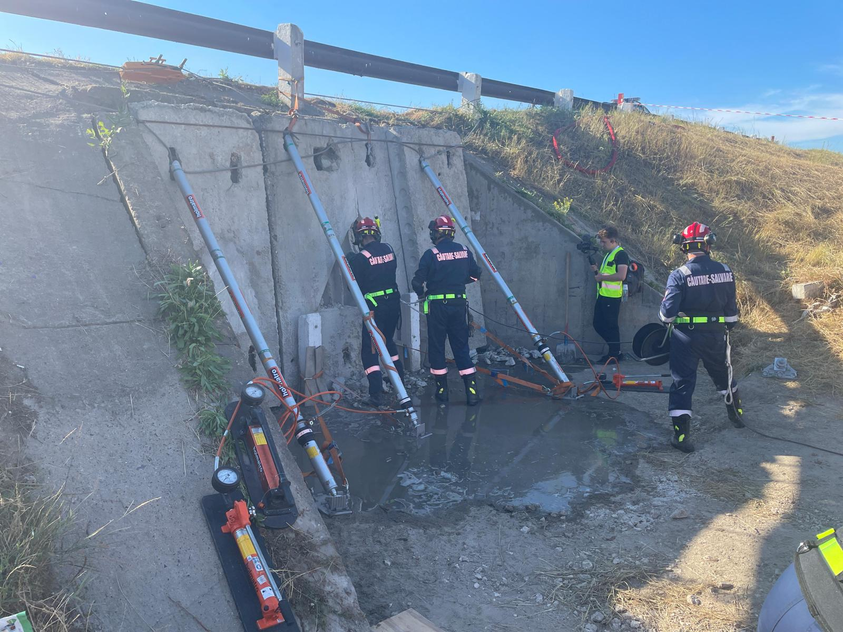
Picture 9. The road accident in the road tunnel.
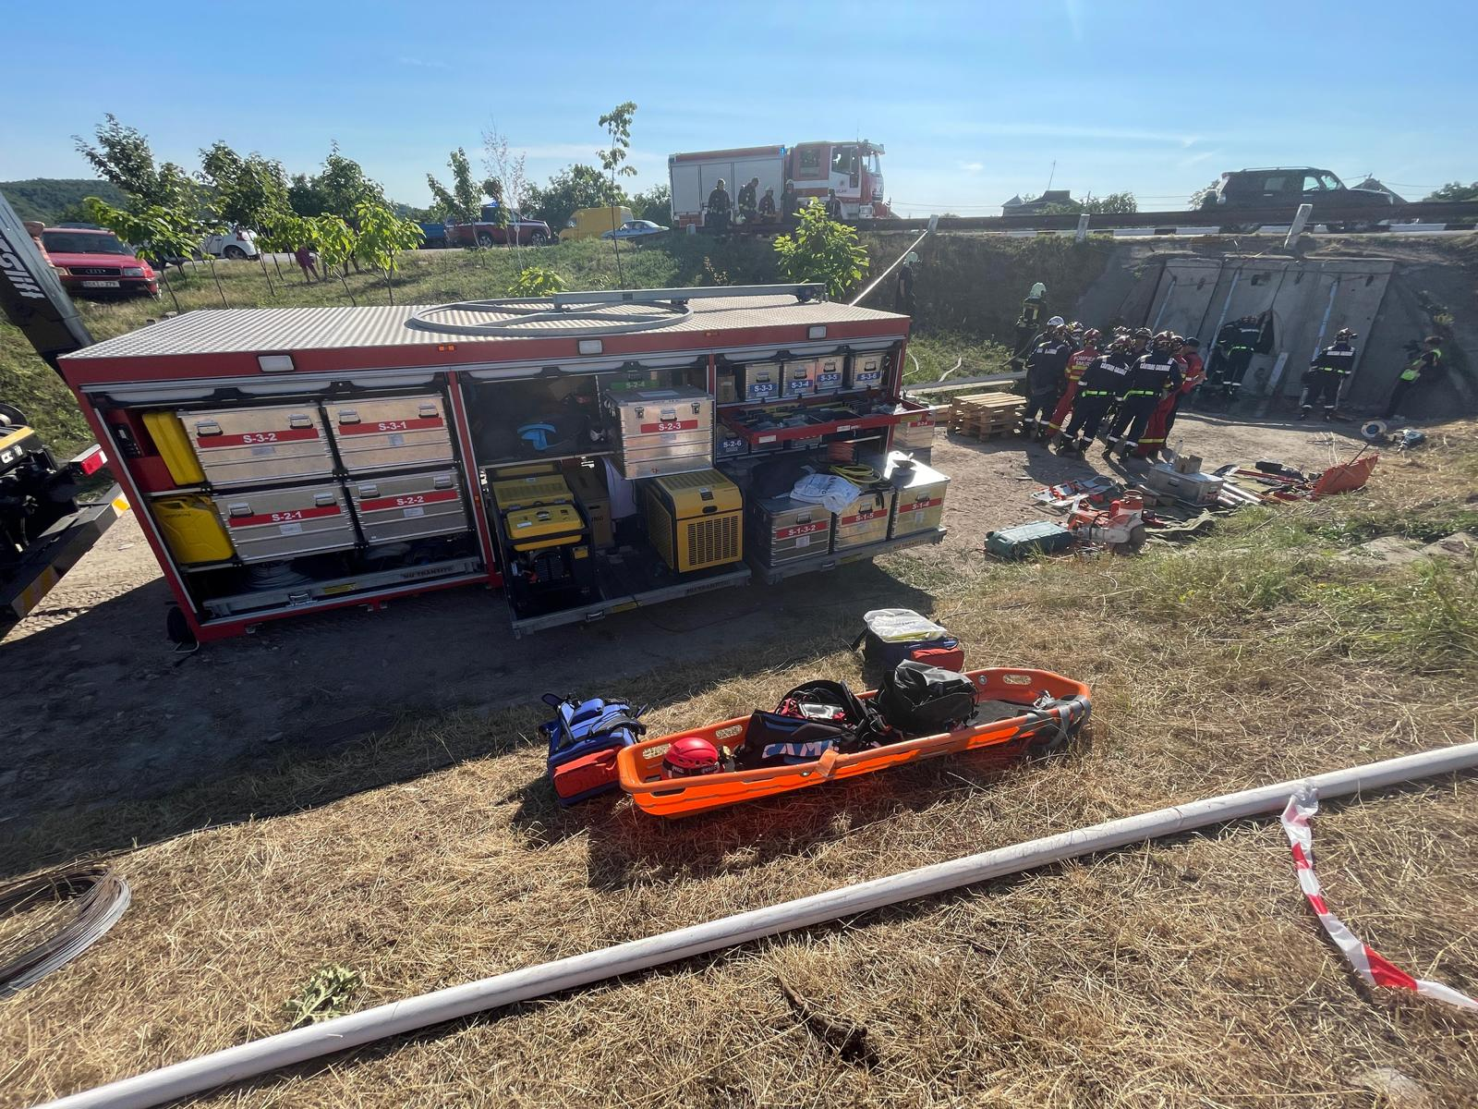
Picture 10. The road accident in the tunnel.
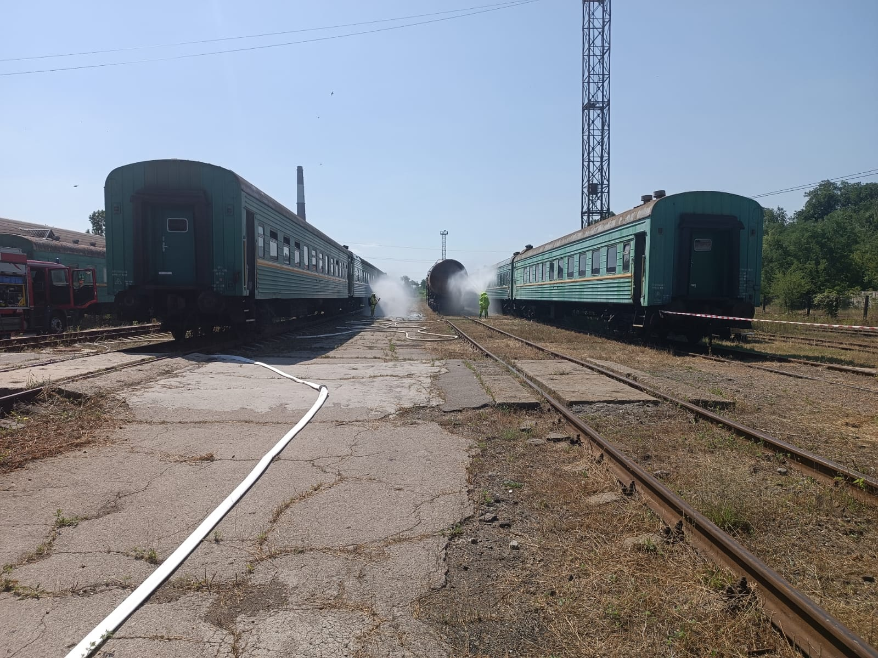
Picture 11. The leakage of hazardous substance from the train tank carriage.
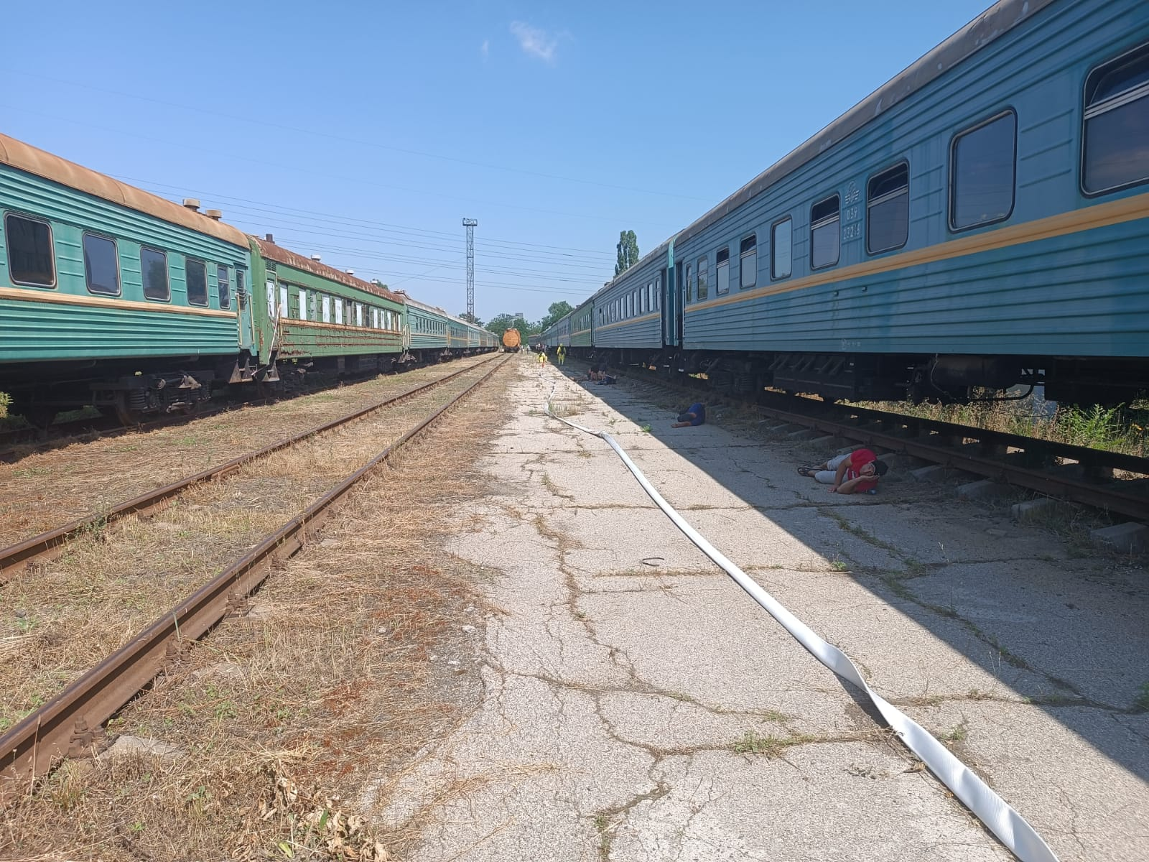
Picture 12. The leakage of hazardous substance from the train tank carriage.
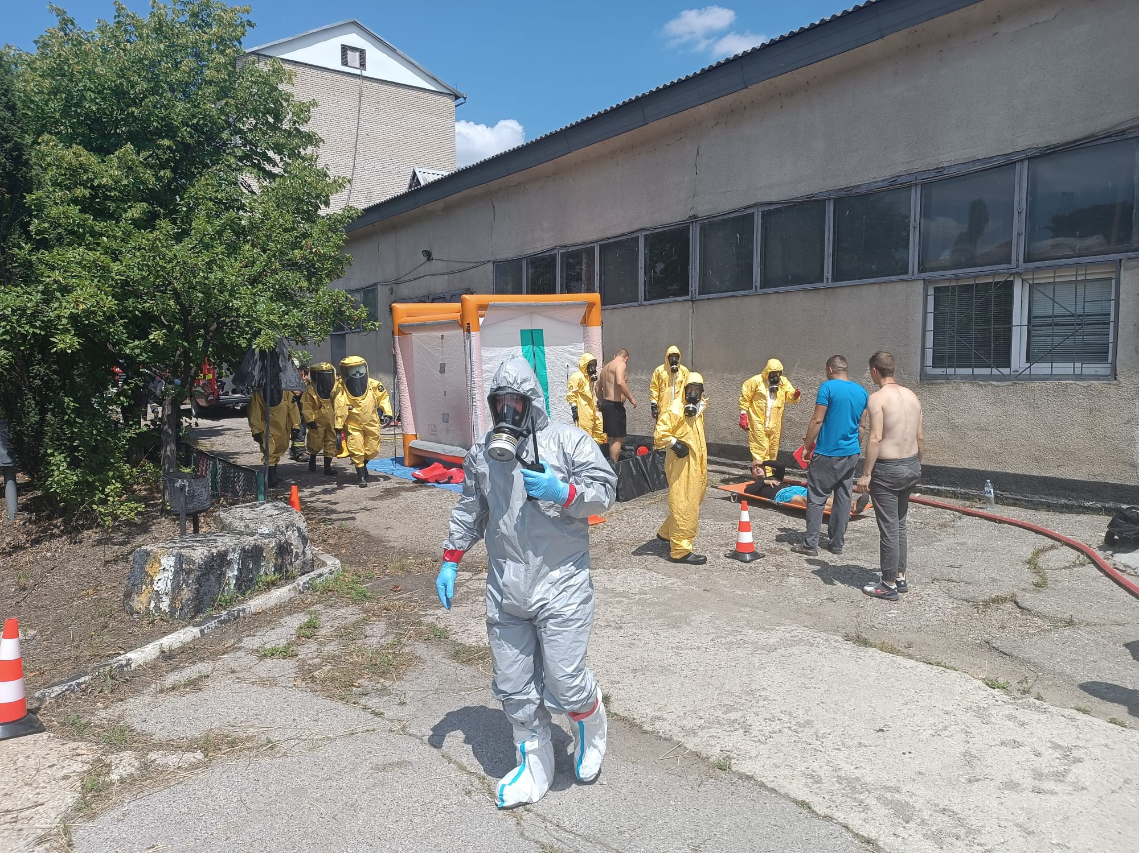
Picture 13. The leakage of hazardous substance from the train tank carriage.

IV. FSX Worksites
Eight different worksites were used during exercise to play 8 different events and 27 injects of the FSX.
Worksite #1. “Liquidation of Catastrophic Flood”, Dam at Razeni Lake; " N 46.748120; E 28.939825
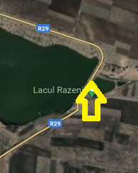
- Episodes: Event I, Injects I.1., I2, I3, I4
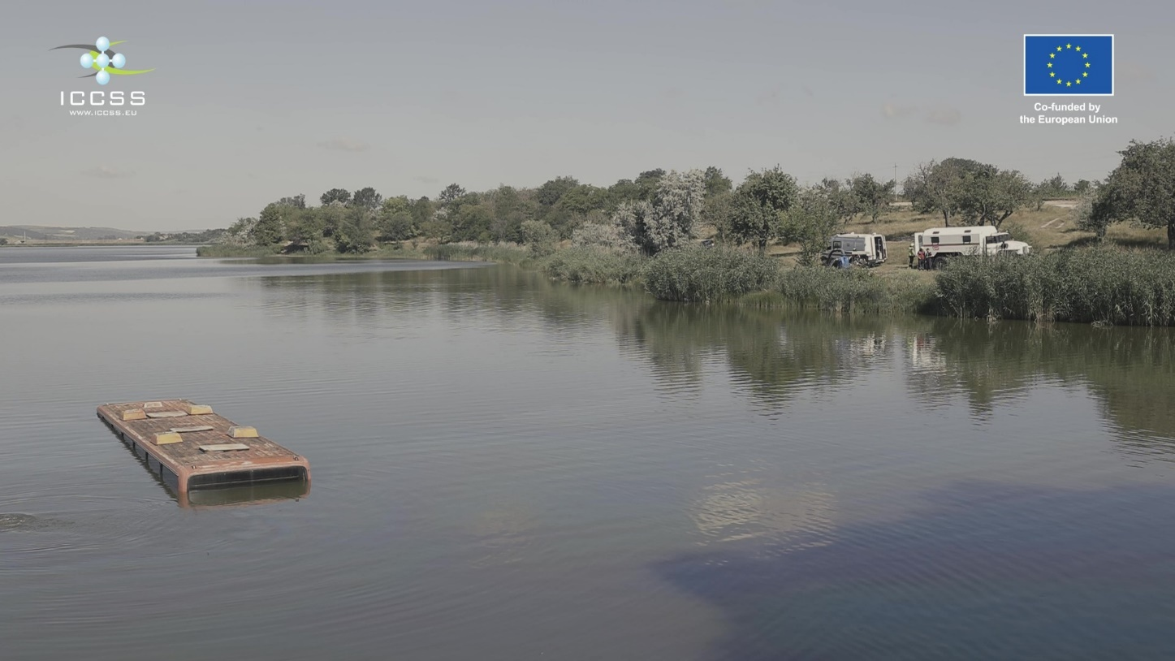
Worksite #2. “Aviation Accident”, Forest 5.3 km South-West (by road) from BoO;
N 46.730490; E 28.872327
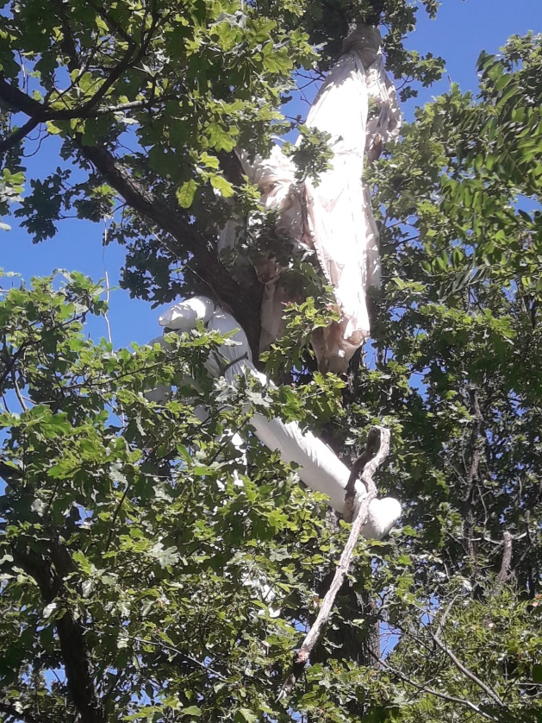
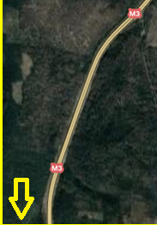
- Episodes: Event I, Injects II.1 and II.2
Worksite #3. “CBRN Incident”, SRL “Doina” VIN; N 46.759166; E 28.922658
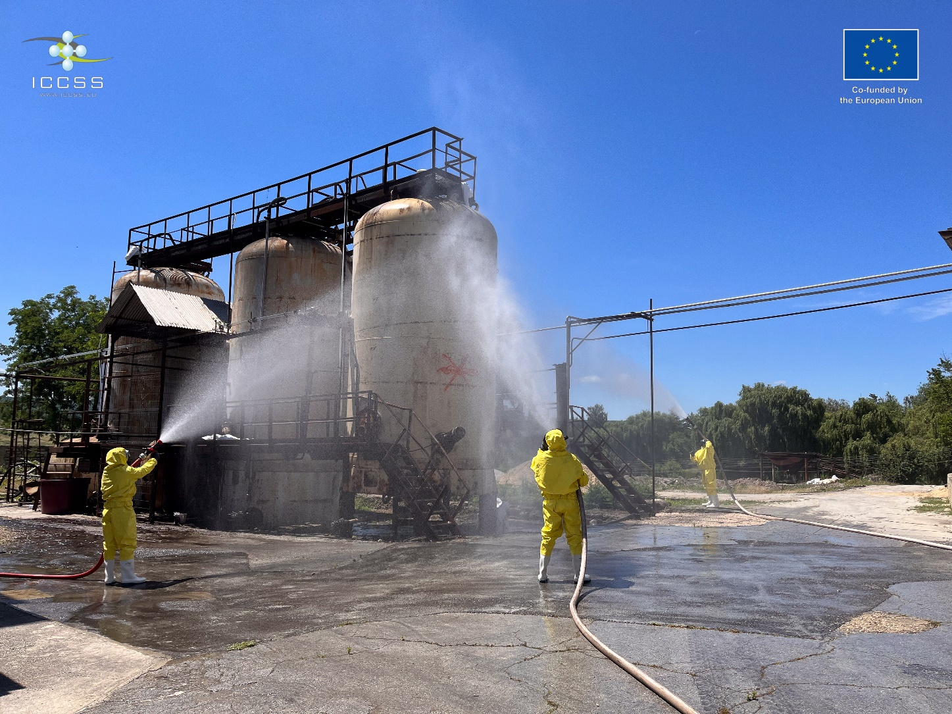
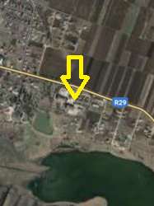
- Episodes: Event III, Injects III.1 and III.2

Worksite #4. “Rescue Action in Transport Accident”, Highway M3 Bridge
N 46.756367; E 28.899895
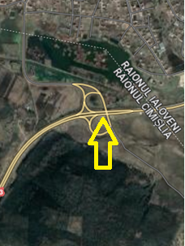
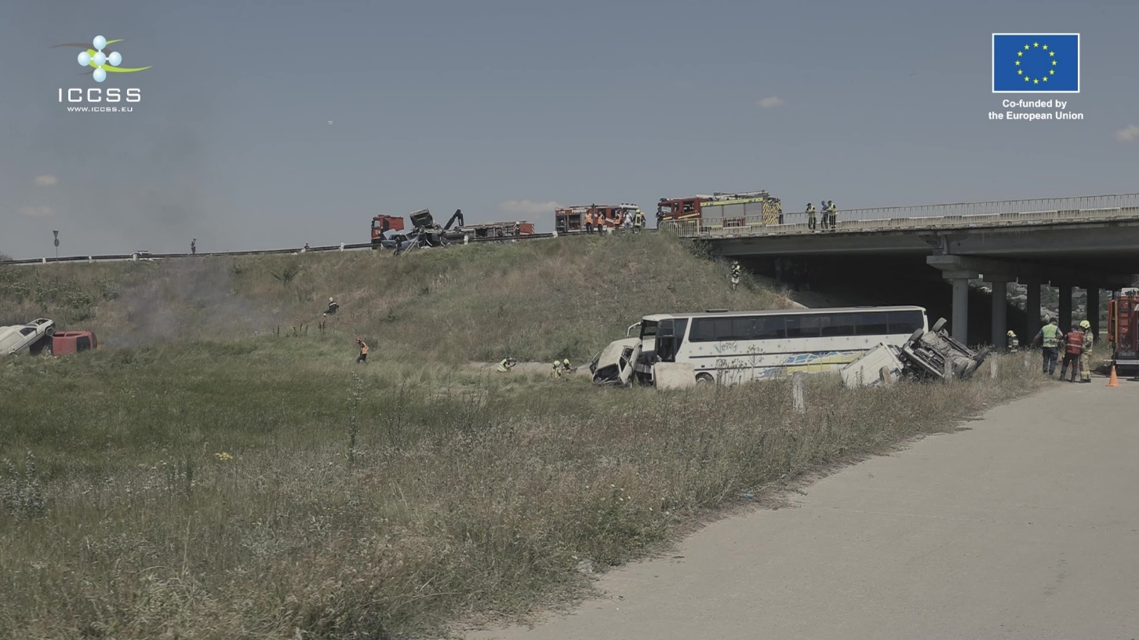
- Episodes: Event IV, Injects IV.1, IV.2 and IV.3

Worksite #5. “Fire in Block of Apartments”, 5-store Building next to BoO;
N 46.763348; E 28.914980
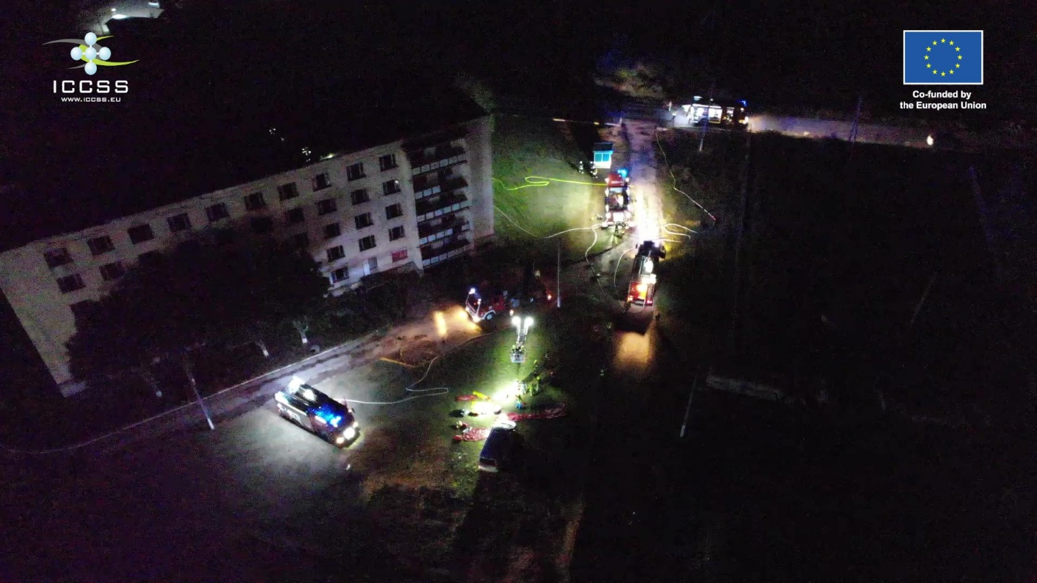
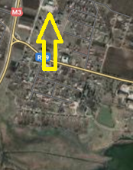
- Episodes: Event V, Injects V.1 and V.2

Worksite #6. “Road Accident in the Tunnel”, Tunnel under Highway M3, located close to BoO;
N 46.762655; E 28.912683
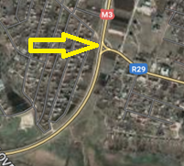
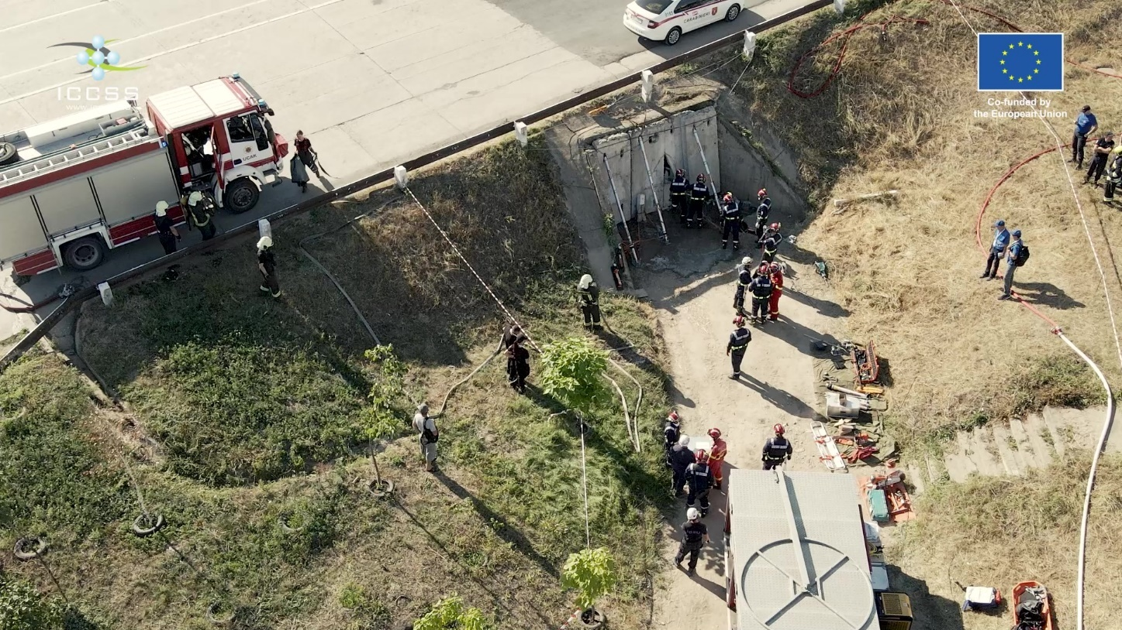
- Episodes: Event VI, Injects VI.1 and VI.2

Worksite #7. ”Chemical Accident at Railway Station”, Railway siding in Chisinau;
N 46.979255, E 28.908686
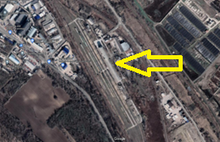
- Episode: VII
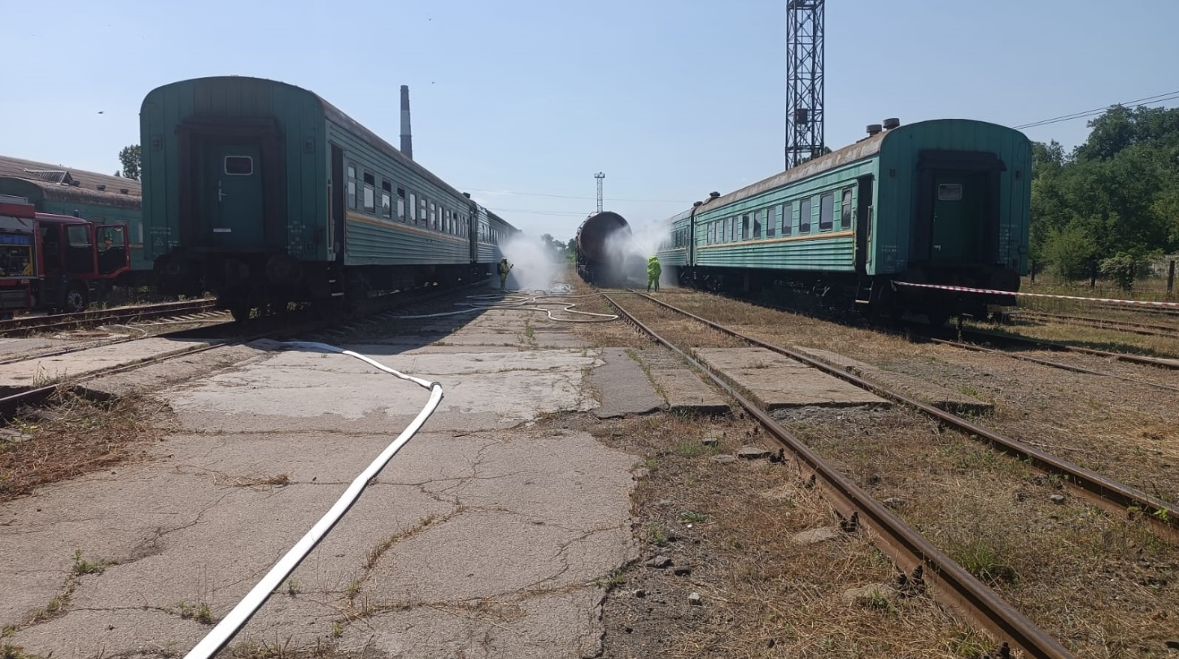

Worksite #8. “Extinguishing Forest Fire”, Forest 500m south from bank of Lake Razeni;
N 46.744527; E 28.932547
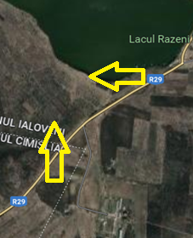
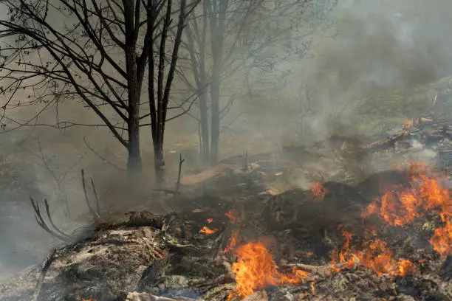
Episodes: Event

