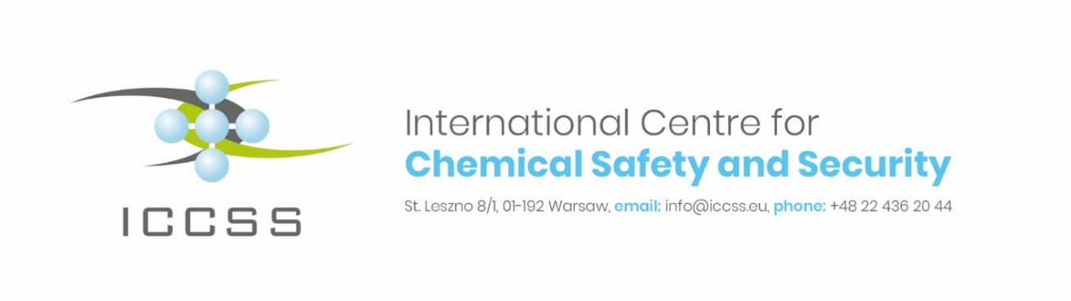**COVID-19 impact on chemical activities/facilities**

**Outcomes of ICCSS Survey and Recommendations**

*New global security challenges and threats include the re-emergence of chemical weapons use and chemical terrorism in the regions of concern, including the Middle East.*

*COVID-19 pandemic has been another significant challenge for chemical activities around the world. Lockdowns were established all over the world. Closed borders, transport and travel restrictions, have a major impact on chemical supply chain.*

*ICCSS has conducted a survey to monitor COVID-19 impact on safety and security and cybersecurity in chemical activities, with an emphasis on production, transport, storage and use of chemicals, and impact on regulations and .*

*ICCSS survey confirmed that chemical activities have been affected by COVID-19 outbreak, with immediate impacts on disrupting supply chain, reduced staffing, diminished monitoring and controls, and growing cyber threats, including increase in phishing attacks and online scam.*

1. **Modalities and content of the Survey.**
2. Main task of the ICCSS Survey was to address COVID-19 impact on chemical activities in the whole chemical supply chain with an emphasis on chemical production, transport, storage and controls/monitoring of chemicals in the Middle East and Eastern Europe.
3. The Survey was completed with an active engagement of the ICCSS Global Team Members around the world. ICCSS partners from the ICCSS led EU-CHEM-REACT program in the Eastern Europe and the Middle East Chemical Security program have also actively participated.
4. The survey was voluntary and anonymous.
5. The survey was conducted between May and September 2020.
6. The following 3 major areas were covered in the ICCSS survey: Pandemics in chemical activities (whether surveyed activity/facility included pandemic in emergency plans); How local communities, chemical industries and chemical regulators were affected by COVID-19, and measures introduced in activity/facility to mitigate COVID-19 impact, including changes in chemical activity/facility organisation/management; changes in chemical activity/facility work organisation; Health measures.
7. The survey’s questions are contained in the attachment.
8. **SURVEY FINDINGS.**
9. ICCSS survey confirmed that chemical activities/facilities were not prepared for COVID-19 since pandemics threats were not part of emergency plans.
10. There were immediate health measures introduced, based on government regulations, which included: testing employees for COVID-19; screening measures (temperature checks for Staff entering facility), use of personal protection equipment, including masks and providing hygiene products
11. None of the surveyed activities/facilities included pandemic in emergency plans.
12. Several of the chemical activities/facilities witnessed the following (one or several) COVID-19 negative impacts, including changes in supply chain, reduction of operations, Staff reductions, ease of regulatory controls, including waivers for requirements, and reduction of inspection activities, increase of cyber threats and reduction of mandatory trainings.
13. In order to mitigate COVID-19 impact the following changes in chemical activity/facility work organisation were introduced: non-visitor policy, distancing at work stations; working from home; isolation of core Staff, quarantine after work travel.
14. While the safety measures were introduced at every surveyd chemical activity/facility, there were significant differences in security measures among facilties. The facilities management concentrated mainly to mitigate immediate problems with an emphasis on disruption of supply chain, reduction of operations, Staff reductions.
15. Disruption of supply chain resulted in appereance of new or unknown chemical suppliers from the Middle East and South East Asia. The threat of increased substandard and/or falsified chemical products increased, including medical products, fertilizers and pesticides.
16. Reduced and/or simplified manadatory supervision/controls of chemicals could lead that unknown suppliers and false chemical products, could enter legal supply chain.
17. A new tendency to introduce distance monitoring/inspection of chemical operations and distance work, combined with increase in phishing attacks and online scam, further deteriorates cybersecurity in chemical facilities and activities.
18. Reduced security screening of new Staff, due to technical Staff shortages, could ease potential purpatrators to enter core activities in chemicla supply chain.
19. A noticeable reduction in field, real trainings and exercises, due to lack of relevant safety security pandemic procedures, could lower competences and preparedness and response to chemical emergencies.
20. **ICCSS CONCLUSIONS and RECOMMENDATIONS**
21. While nuclear and bio operators around the globe have contingency plans for pandemics, there are no such similar policies and practices in chemical sector.
22. The combination of the negative findings/trends presented in the Survey would increase chemical threat locally, nationally and worldwide. This could undermine safety and security and cybersecurity with emhpasis on production, transport, storage and use of chemicals.
23. It is possible chemical operators and regulators could be facing an increased threat. Therefore chemical safety and security and cybersecurity shall remain a top priority of national and international efforts in time of COVID-19.

**We therefore recommend:**

1. Chemical regulators and operators should join efforts to protect legal supply chain and secure business continuity and respond to reduction of operations, Staff reductions, ease of regulatory controls, including waivers for requirements, and reduction of inspection activities, increase of cyber threats and reduction of mandatory trainings.
2. The chemical safety and security measures to mitigate COVID-19 impact shall concentrate on identification of Lessons Learned, inclusion of pandemic in emergency plans, priority given to cybersecurity and reliability (to migitate distance work and increase in remote controls/inspections), and field, on-site trainings and exercises.
3. ICCSS invites national and international partners to develop guidelines, best practices and norms, including model pandemics plans for chemical activities (production, storage, transportation, monitoring and controls), pandemics safety security guidelines for CBRN related training and exercises.