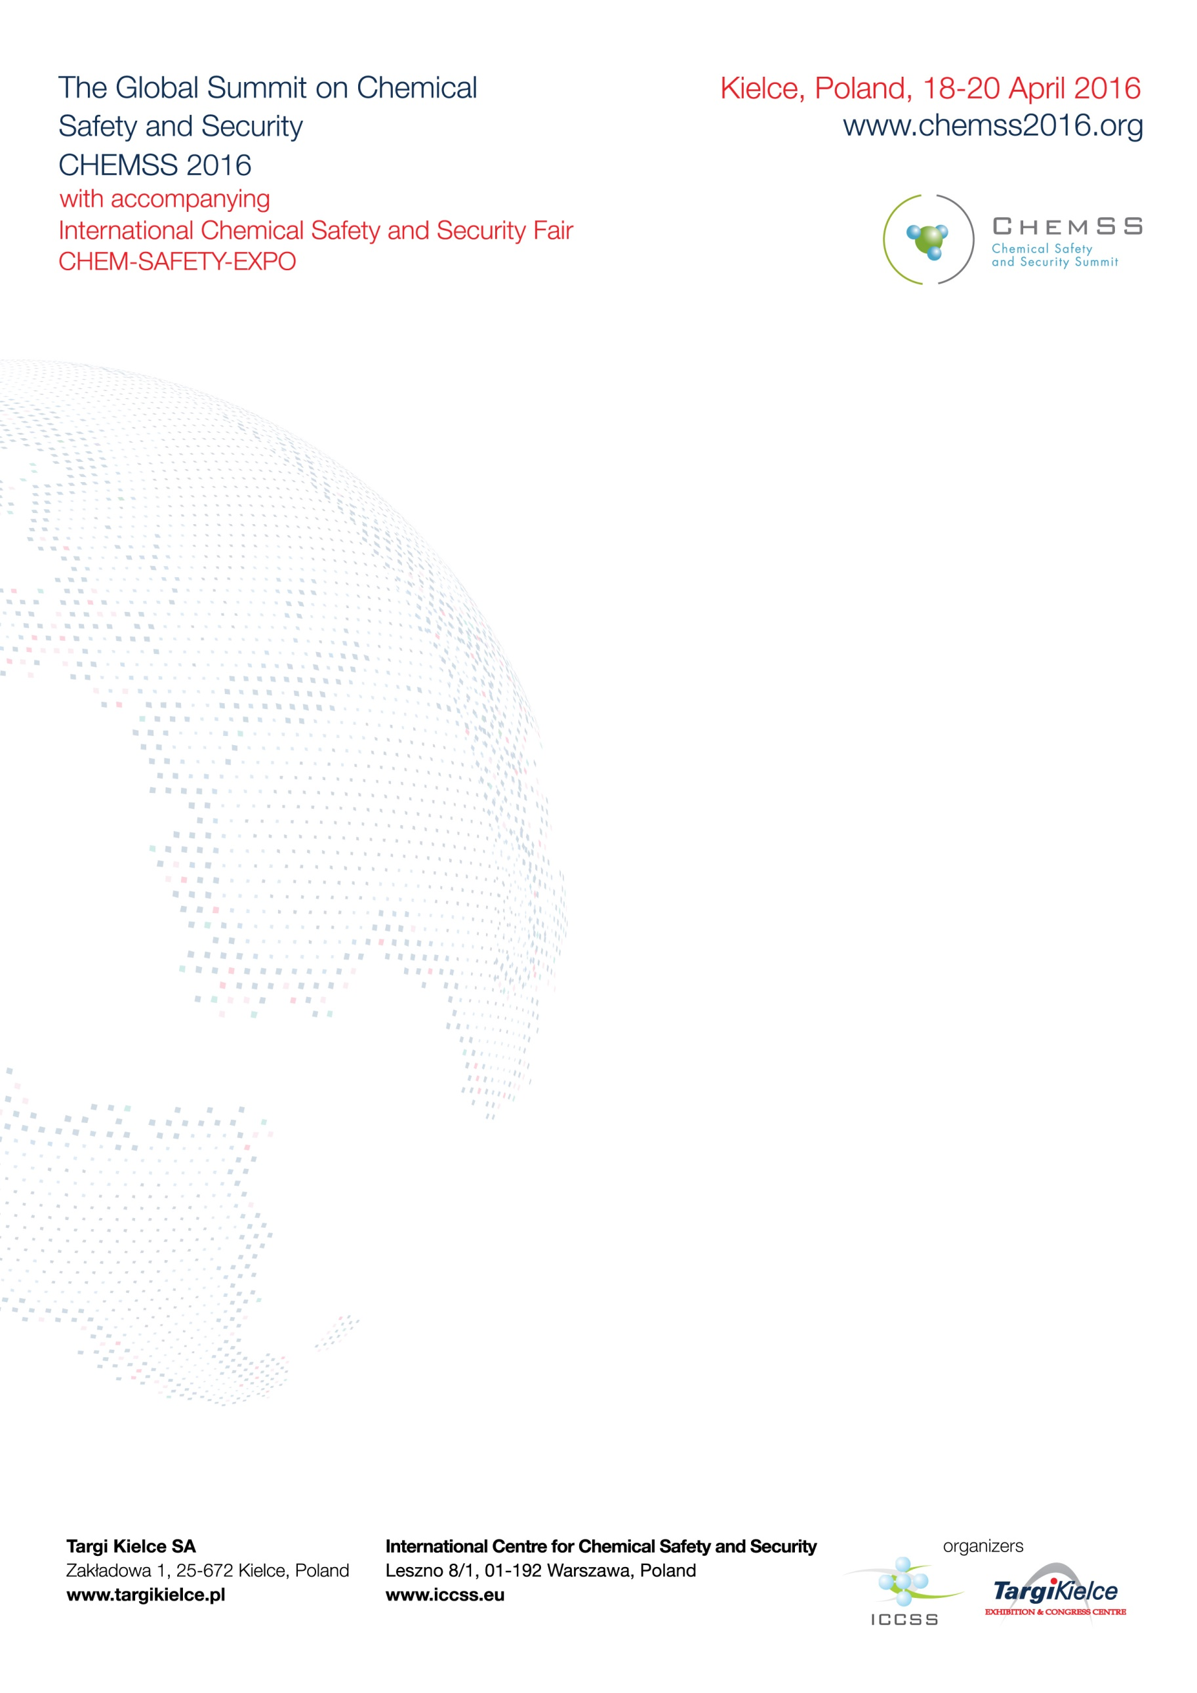

**GLOBAL SUMMIT ON CHEMICAL SAFETY AND SECURITY**

**KIELCE, POLAND, 18-20 APRIL 2016**

**www.chemss2016.org**

**SUMMIT DECLARATION**

**On the development of international cooperation to enhance chemical safety**

**and security and the promotion of a global chemical security culture**

Summit participants noted the important support of the International Center for Chemical Safety and Security (ICCSS) and the Government of Poland in providing global leadership on chemical safety and security, and expressed appreciation for both the summit in Kielce and the prior conference in Tarnow.

The importance of chemical industry and activity is on the rise globally. Chemical safety and security, including the development, production, infrastructure and full supply chain of chemicals are therefore of increasing importance for governments, chemical industry, and the users of chemistry. Promoting a chemical safety and security culture will provide greater assurances that national chemical management systems can perform their functions to handle chemicals in a sound and safe manner, prevent misuse of hazardous chemicals, and contribute to environmental protection.

Acknowledging that safety and security measures have the common aim of protecting human life, health, and the environment, we agree that there is a need for a coherent and synergistic approach at national and international levels in this regard and introduction of chemical safety and security culture. This culture facilitates implementation and management of safety and security prerequisites, including bilateral and multilateral cooperation.

All stakeholders, including governments, regulatory bodies, industry, academia, non-governmental organizations, and the media, are encouraged to fully commit to enhancing chemical safety and security culture and to maintain robust communication and coordination of activities at national and international levels.

National and international efforts are welcome to provide relevant support and assistance to enhance safety and security in all areas of chemical activities.

The International Meeting on Chemical Safety and Security taking place on 8-9 November 2012 in Tarnow, Poland, organized by the Organization for the Prohibition of Chemical Weapons (OPCW) and the International Centre for Chemical Safety and Security (ICCSS) in Warsaw, attended by the representatives of 56 countries, many international and regional organizations, academia and civil society, was an important event to further the international cooperation to enhance global chemical safety and security. This most recent Global Summit on Chemical Safety and Security, taking place 18-20 April, 2016 in Kielce, Poland, represents another historic step forward.

**The international cooperation to enhance chemical safety and security could include the following general considerations, goals, guidelines, principles, and the development of chemical safety and security culture**:

1. **General considerations**
2. A comprehensive approach toward promoting chemical safety and security goes beyond chemical plants and shall include introduction of safety and security culture and its promotion to all relevant stakeholders. The stakeholders include governments and relevant national agencies; industries, including chemical associations and private industries; laboratories; regional and international organizations involved in the international safety and security and peaceful application of chemistry; and civil society, including academia, non-governmental organizations, independent experts, and media.
3. Strict chemical safety and security measures must be applied throughout the full chain of production, infrastructure, transportation, storage, use, and disposal of chemicals in order to support effective barriers against misuse and diversion of chemical agents and materials.
4. The basic principles of chemical security culture include shared values, beliefs, and behavior patterns leading to promotion, use, and development of safety management systems for humans; and environmental protection and security measures, including prevention, protection, detection of, and response to theft, sabotage, unauthorized access, illegal transfer, or other malicious acts involving both the materials that can be used for unconventional terrorist purposes and their associated facilities.
5. A number of countries and organizations have promoted new program activities and announced plans to enhance chemical safety and security at the national and regional levels. They intend, *inter alia*, to develop national and international programs and centers on chemical safety and security, as well as use of the regional Centers of Excellence.
6. For more than 25 years, the “Responsible Care” program of industry has promoted safety and, since year 2001, also security practices that safeguard our workplaces, communities, and the broader environment. Corporate social responsibility and best environmental and public health practices are key parts of these efforts.
7. These national, international and industry initiatives should receive support of all relevant stakeholders to advance chemical safety and security at national levels, and in all relevant spheres of chemical activities.
8. The establishment of the International Centre for Chemical Safety and Security (ICCSS) serves the purpose of the practical promotion and development of a chemical safety and security culture. The Centre offers both national and international partners a venue for cooperation in capacity-building, training, best practices exchange, socially responsible management, and cooperation between professionals in the area of chemical safety and security.
9. **General goals**
10. To promote chemical safety and security by:
    1. bringing the issue to the agenda of national policies,
    2. improving efficiency in capacity-building and exchanging information on best practices with regard to chemical safety and security,
    3. building and improving national and international coordination of chemical safety and security actors,
    4. promoting application of research outcomes in assessing impacts on the environment and public health, and
    5. building awareness-raising programs for the public and for policy makers on issues relevant to chemical safety and security;
11. To promote mechanisms for national, regional, and international networking to share experiences in these areas among all relevant stakeholders;
12. To promote solutions which will be continued, sustainable, affordable, and accountable globally, with due regard to the needs of developing countries and countries with economies in transition;
13. To establish and/or promote mechanisms to identify and analyze countries' needs for assistance, upon their request, in chemical safety and security, and build partnership and cooperation with relevant national and international capacities to accommodate these needs and programs; and
14. To engage private sectors to build public-private partnerships to enhance chemical safety and security worldwide.
15. **General guidelines**
16. To seek a comprehensive and synergistic approach among all relevant international treaties and agreements (including the Chemical Weapons Convention, and the Basel, Minimata, Rotterdam, Stockholm, and other relevant conventions) for capacity-building that develops chemical safety and security in all areas pertaining to chemicals and wastes;
17. To facilitate universal adherance to, and full national implementation of all relevant conventions;
18. To provide demand-driven assistance that is respectful of recipient countries’ needs, identification, and ownership of decision-making;
19. To create networking to facilitate information exchange and to ensure that all partners are aware of each other’s work in the area of chemical safety and security;
20. To coordinate efforts to maximize inter-operability, and to utilize the role of governments, as well as the complementary roles of multilateral partners; and
21. To structure finances in a way that is more predictable, reliable, and transparent and could enhance mutual accountability.
22. **General Principles of enhancing chemical safety and security**
23. To focus on enhancing awareness and best practices through training, seminars, workshops, and other education processes in broad areas of chemical security and safety issues;
24. To strengthen international cooperation to promote a chemical safety and security culture globally. These efforts should also engage researchers from academia and private industry;
25. To promote implementation of the World Health Organization (WHO) International Health Regulations (IHR 2000) to improve global abilities to detect, assess, report, and respond to health events of international concern;
26. To promote and work in line with the United Nations, the UN Environmental Program (UNEP), the Strategic Approach to International Chemical Management (SAICM), the Inter-Organization Program for Sound Management of Chemicals (IOMC), and national and international activities towards sound management of chemicals;
27. To promote the implementation of the provisions of the Chemical Weapons Convention (CWC) and the development of the Organization for the Prohibition of Chemical Weapons (OPCW) as a platform for cooperation among all stakeholders to reduce chemical threats; and
28. To promote the comprehensive implementation of the provisions of United Nations Security Council Resolution 1540 (2004);
29. To promote the implementation of the Paris Agreement on Climate Change.
30. **Development of chemical safety and security culture**
31. Chemical safety and security culture could be considered as an assembly of beliefs, attitudes, and patterns of behavior which will strengthen and/or complement physical security, procedures, and legislation, in their mission to achieve intended security goals.
32. In the age of globalized and diversified communications, codes of conduct, ethics, and other similar sources of individual voluntary commitments are becoming increasingly effective tools of culture promotion.
33. Safety and Security culture promotion is likely to produce codes of conduct and practical results if its underlying standards are embedded in national values and traditions.
34. Security culture is no longer limited to the facility or even industry level, as continuously expanding and increasingly vulnerable supply chains, with a multitude of diverse and overlapping players, create much larger areas of chemical security implementation, and thus need to be practiced creatively throughout the whole life-cycle of chemicals.
35. Chemical safety and security culture could derive its strengths or weaknesses from overall organizational culture at the level of individual chemical companies. The security culture is a part of an overall organizational culture, and it can significantly strengthen or weaken the latter.
36. The manifestation of safety and security culture is most important at the organizational and individual levels, but the goals can be fully achieved only if there are adequate inputs from high levels, i.e. from international and national levels.

**We urge all stakeholders, including the participants in the Global Summit on Chemical Safety and Security – Chemss2016, to promote this Declaration directly to their organizations and networks and through social media more broadly. We will be successful in building a more safe, secure, and sustainable world chemistry with global outreach, awareness-raising, national and industry best practices exchanges, capacity building and cooperation between professionals worldwide.**

Kielce, Poland, 20 April, 2016